**PYTHON**

**Python Introduction**

**What is Python?**

Python is a popular programming language. It was created by Guido van Rossum, and released in 1991.

It is used for:

* web development (server-side),
* software development,
* mathematics,
* system scripting.

Python Features Python is a dynamic, high-level, free open source, and interpreted programming language. It supports object-oriented programming as well as procedural-oriented programming. In Python, we don’t need to declare the type of variable because it is a dynamically typed language. For example, x = 10 Here, x can be anything such as String, int, etc. In this article we will see what characteristics describe the python programming language.

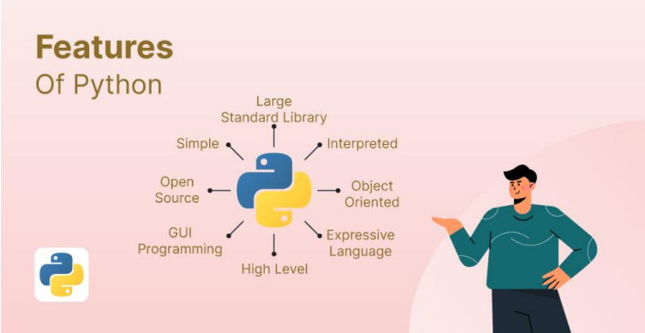

**Features in Python**

1. Free and Open Source
2. Easy to code Python is a high-level programming language.
3. Easy to Read As you will see, learning Python is quite simple.
4. Object-Oriented Language One of the key features of Python is Object-Oriented programming.
5. Interpreted Language:

**Why Python?**

* Python works on different platforms (Windows, Mac, Linux, Raspberry Pi, etc).
* Python has a simple syntax similar to the English language.
* Python has syntax that allows developers to write programs with fewer lines than some other programming languages.
* Python runs on an interpreter system, meaning that code can be executed as soon as it is written. This means that prototyping can be very quick.
* Python can be treated in a procedural way, an object-oriented way or a functional way.

**Python Syntax compared to other programming languages**

* Python was designed for readability, and has some similarities to the English language with influence from mathematics.
* Python uses new lines to complete a command, as opposed to other programming languages which often use semicolons or parentheses.
* Python relies on indentation, using whitespace, to define scope; such as the scope of loops, functions and classes. Other programming languages often use curly-brackets for this purpose.

**First Program:**

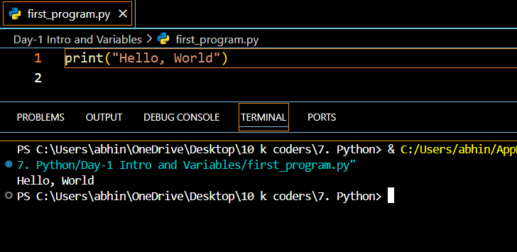

**Python Variables**

Python Variable is containers that store values. Python is not “statically typed”. We do not need to declare variables before using them or declare their type. A variable is created the moment we first assign a value to it. A Python variable is a name given to a memory location. It is the basic unit of storage in a program.

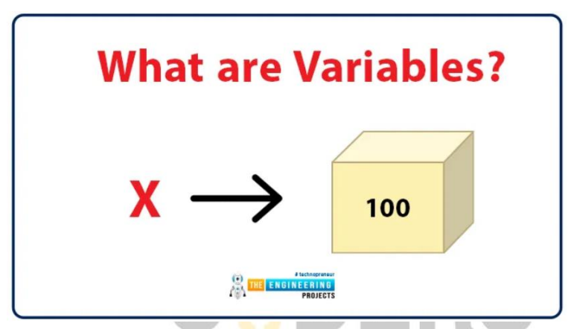

**Example of Variable in Python**

An Example of a Variable in Python is a representational name that serves as a pointer to an object. Once an object is assigned to a variable, it can be referred to by that name. In layman’s terms, we can say that Variable in Python is containers that store values.

var = "10KCoders"

**Variables Assignment in Python**

Here, we will define a variable in python. Here, clearly we have assigned a number, a floating point number, and a string to a variable such as age, salary, and name.

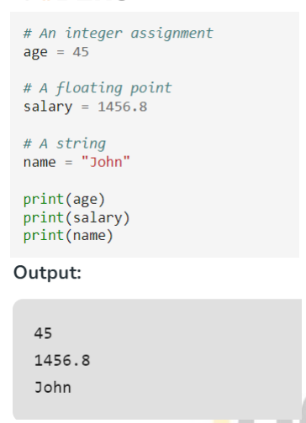

**Declaration and Initialization of Variables**

Let’s see how to declare a variable and how to define a variable and print the variable.

**For example:**

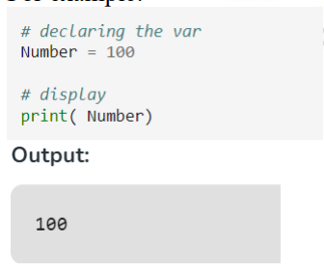

**Redeclaring variables**

in Python We can re-declare the Python variable once we have declared the variable and define variable in python already.

**For example**:

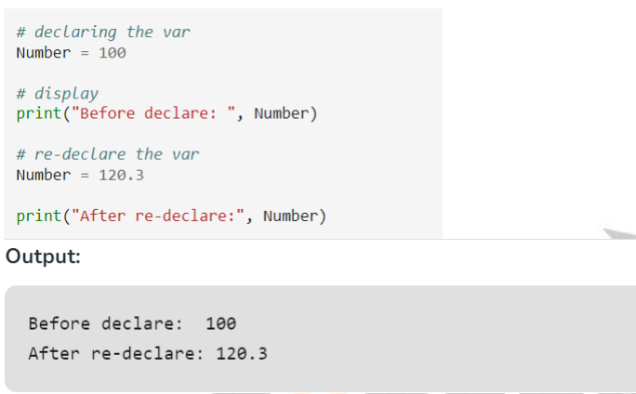

**Python Assign Values to Multiple Variables Also,**

Python allows assigning a single value to several variables simultaneously with “=” operators.

**For example:**

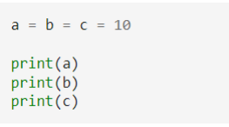

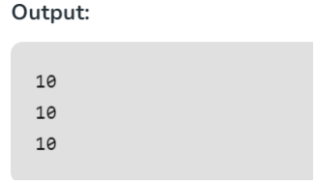

**Assigning different values to multiple variables**

Python allows adding different values in a single line with “,” operators.

**For example**

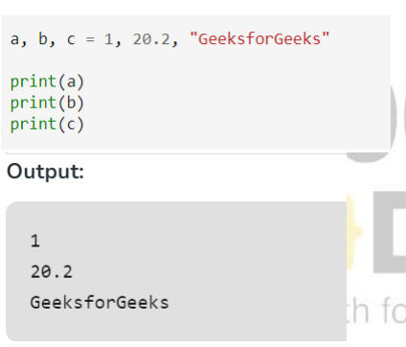

**Python Installation:**

https://www.tutorialspoint.com/how-to-install-python-in-windows

**Python Syntax:**

**Python Indentation**

* Indentation refers to the spaces at the beginning of a code line.
* Where in other programming languages the indentation in code is for readability only, the indentation in Python is very important.
* Python uses indentation to indicate a block of code.

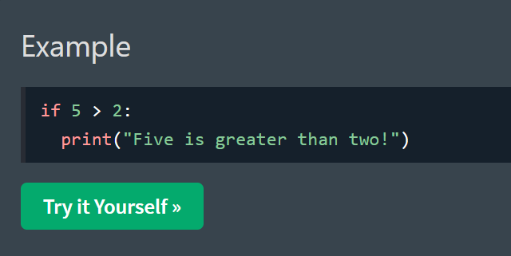

**Python Comments**

* Comments can be used to explain Python code.
* Comments can be used to make the code more readable.
* Comments can be used to prevent execution when testing code.

**Creating a Comment**

Comments starts with a #, and Python will ignore them:

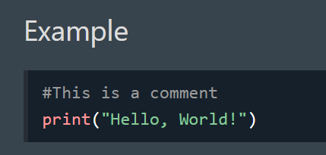

**Multiline Comments**

Python does not really have a syntax for multiline comments.

To add a multiline comment you could insert a # for each line:

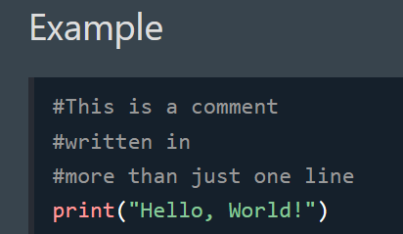

**Python Data Types**

**Python Data Types**

Python Data types are the classification or categorization of data items. It represents the kind of value that tells what operations can be performed on a particular data. Since everything is an object in Python programming, Python data types are classes and variables are instances (objects) of these classes.

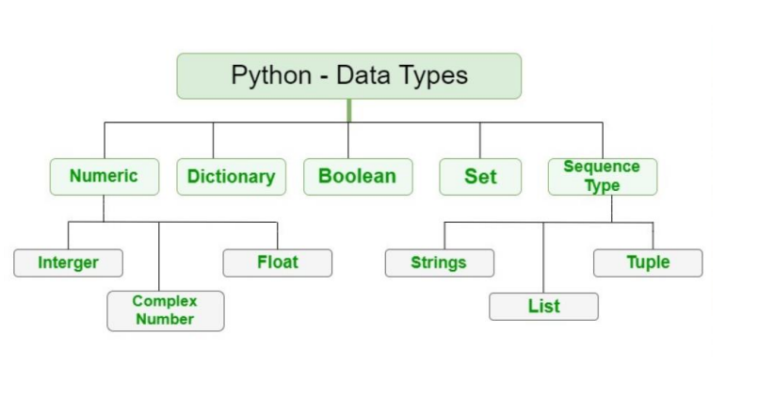

The following are the standard or built-in data types in Python:

* Numeric
* Sequence Type
* Boolean
* Set
* Dictionary

**Numeric Data Types in Python**

The numeric data type in Python represents the data that has a numeric value. A numeric value can be an integer, a floating number, or even a complex number.

**Integers** – This value is represented by int class. It contains positive or negative whole numbers (without fractions or decimals). In Python, there is no limit to how long an integer value can be.

**Float** – This value is represented by the float class. It is a real number with a floating-point representation.

**Complex Numbers** – A complex number is represented by a complex class. It is specified as (real part) + (imaginary part)j .

**For example** – 2+3j

**Note** – type() function is used to determine the type of Python data type.

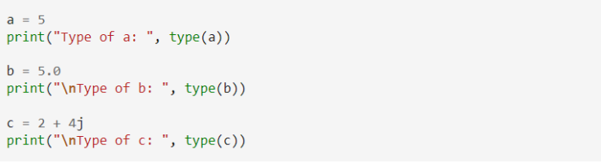

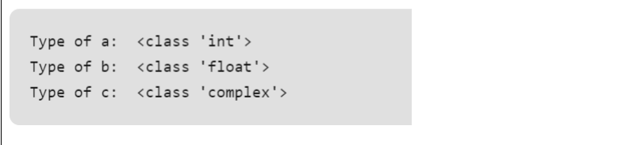

**Sequence Data Types in Python**

The sequence Data Type in Python is the ordered collection of similar or different Python data types. Sequences allow storing of multiple values in an organized and efficient fashion. There are several sequence data types of Python:

* Python String
* Python List
* Python Tuple

**String Data Type**

Strings in Python are arrays of bytes representing Unicode characters. A string is a collection of one or more characters put in a single quote, double-quote, or triple-quote.

**Example:** This Python code showcases various string creation methods. It uses single quotes, double quotes, and triple quotes to create strings with different content and includes a multiline string. The code also demonstrates printing the strings and checking their data types.

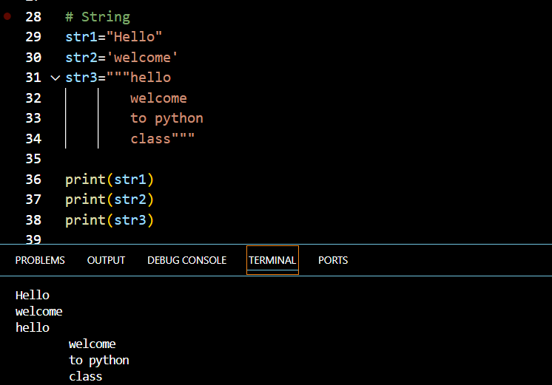

**List Data Type**

Lists are just like arrays, declared in other languages which is an ordered collection of data. It is very flexible as the items in a list do not need to be of the same type.

**Creating a List in Python** Lists in Python can be created by just placing the sequence inside the square brackets[].

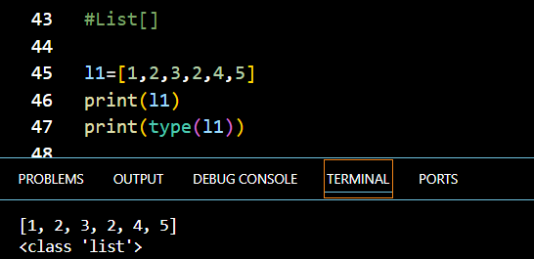

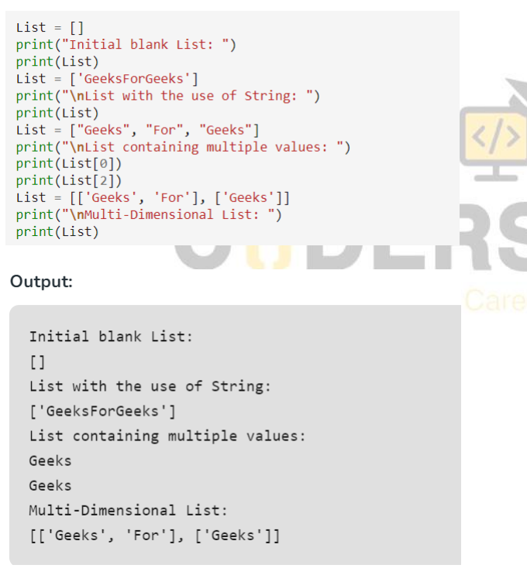

**Tuple Data Type**

Just like a list, a tuple is also an ordered collection of Python objects. The only difference between a tuple and a list is that tuples are immutable i.e. tuples cannot be modified after it is created. It is represented by a tuple class.

**Creating a Tuple in Python**

In Python Data Types, tuples are created by placing a sequence of values separated by a ‘comma’ with or without the use of parentheses for grouping the data sequence

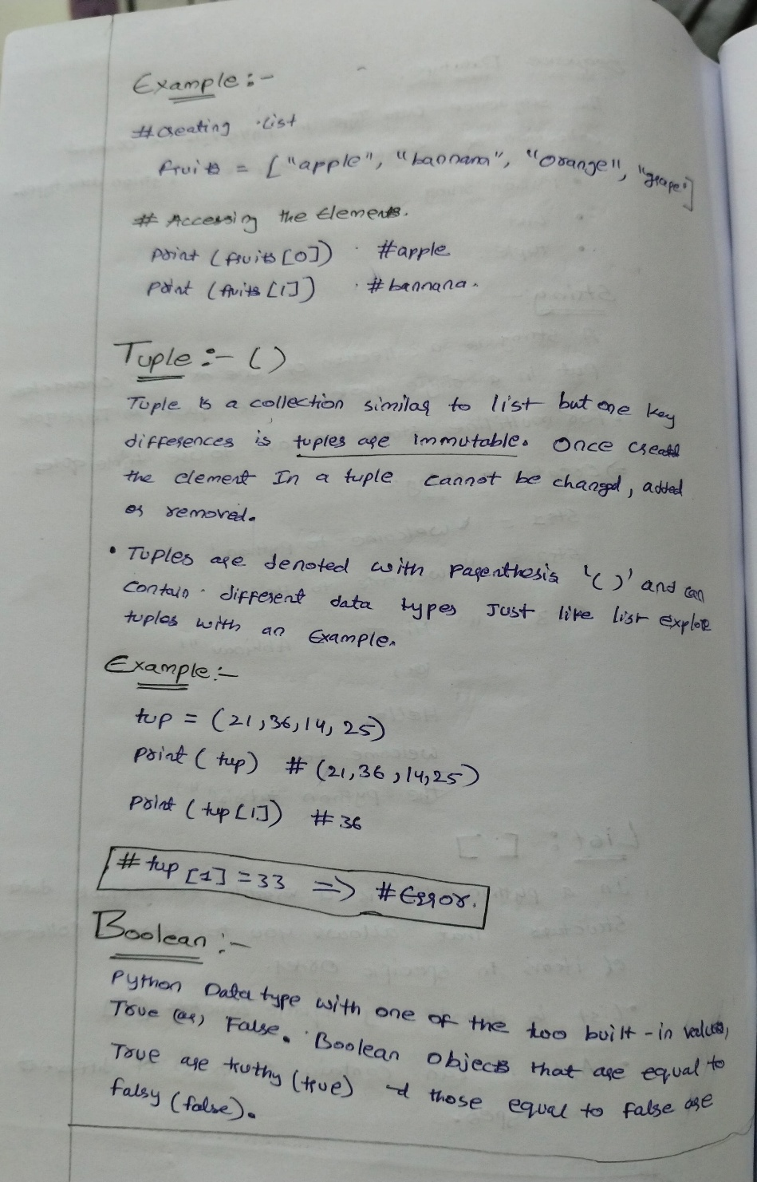

**Boolean Data Type in Python**

Python Data type with one of the two built-in values, True or False. Boolean objects that are equal to True are truthy (true), and those equal to False are falsy (false). However non-Boolean objects can be evaluated in a Boolean context as well and determined to be true or false. It is denoted by the class bool.

**Note** – True and False with capital ‘T’ and ‘F’ are valid booleans otherwise python will throw an error.

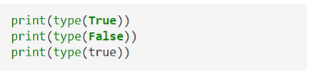

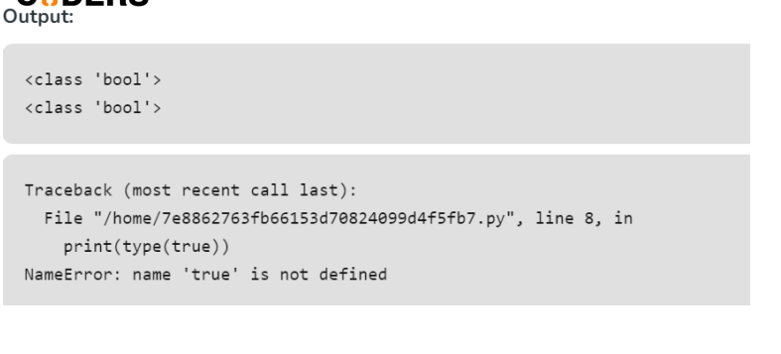

**Set Data Type in Python**

In Python Data Types, a Set is an unordered collection of data types that is iterable, mutable, and has no duplicate elements. The order of elements in a set is undefined though it may consist of various elements.

**Create a Set in Python**

Sets can be created by using the built-in set() function with an iterable object or a sequence by placing the sequence inside curly braces, separated by a ‘comma’. The type of elements in a set need not be the same, various mixed-up data type values can also be passed to the set.

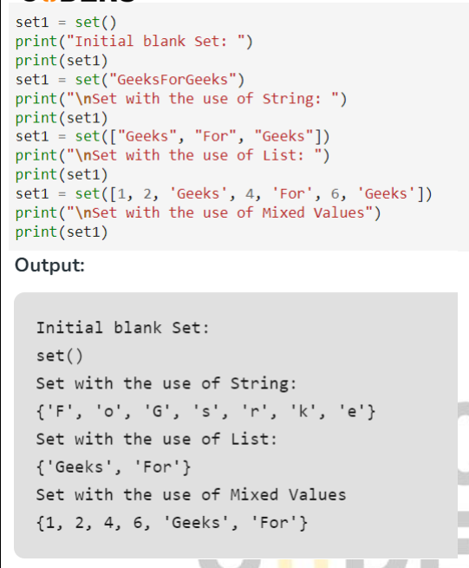

**Dictionary Data Type in Python**

A dictionary in Python is an unordered collection of data values, used to store data values like a map, unlike other Python Data Types that hold only a single value as an element, a Dictionary holds a key: value pair. Key-value is provided in the dictionary to make it more optimized. Each key-value pair in a Dictionary is separated by a colon : , whereas each key is separated by a ‘comma’

**Create a Dictionary in Python**

In Python, a Dictionary can be created by placing a sequence of elements within curly {} braces, separated by ‘comma’. Values in a dictionary can be of any datatype and can be duplicated, whereas keys can’t be repeated and must be immutable.

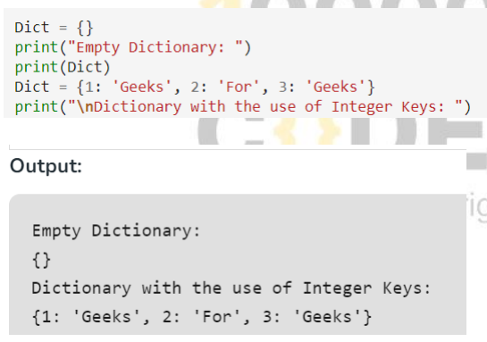

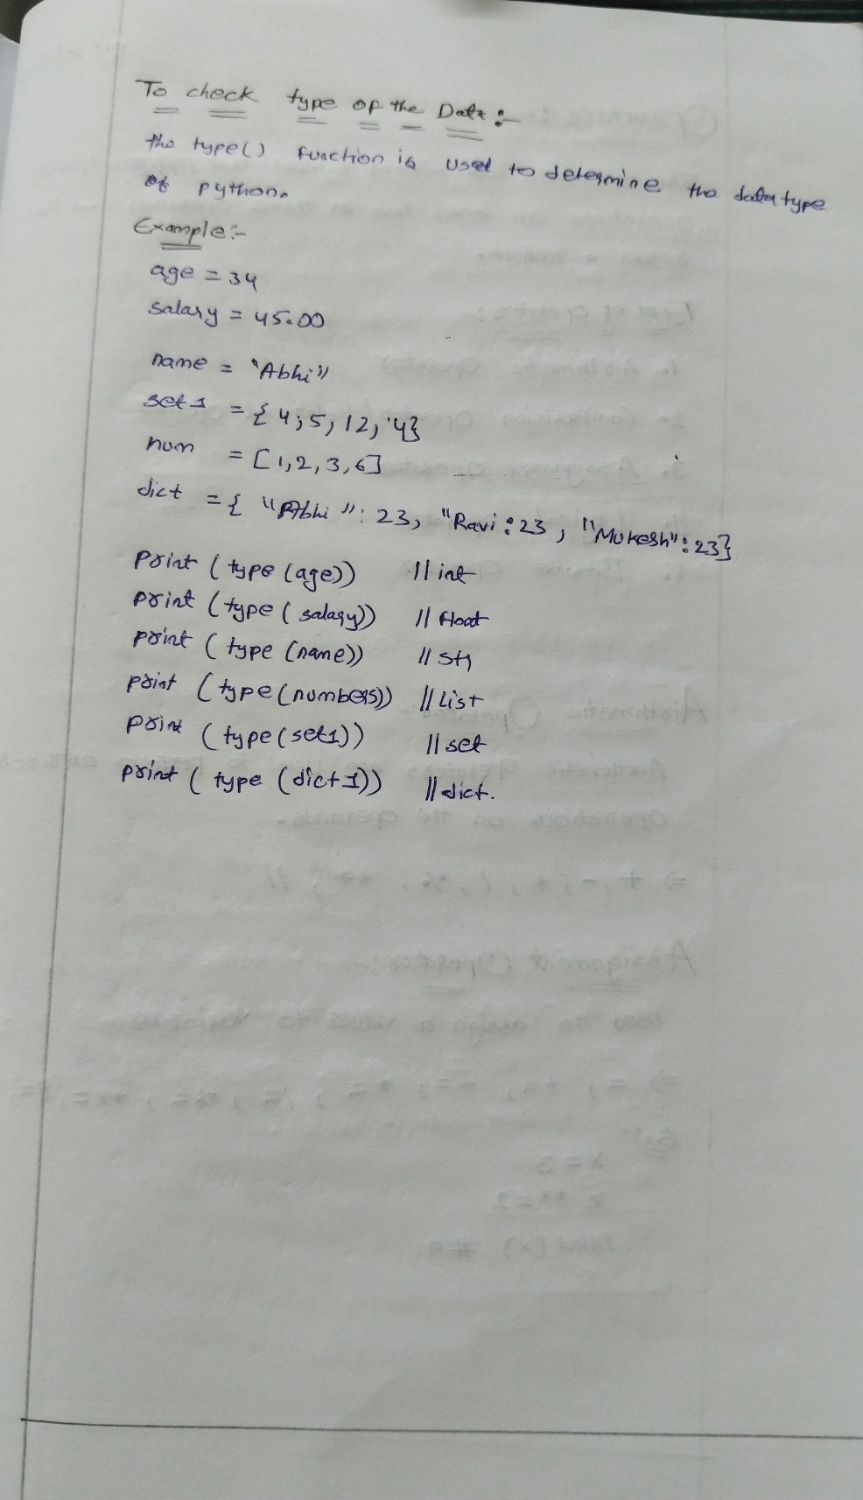

**Operators**

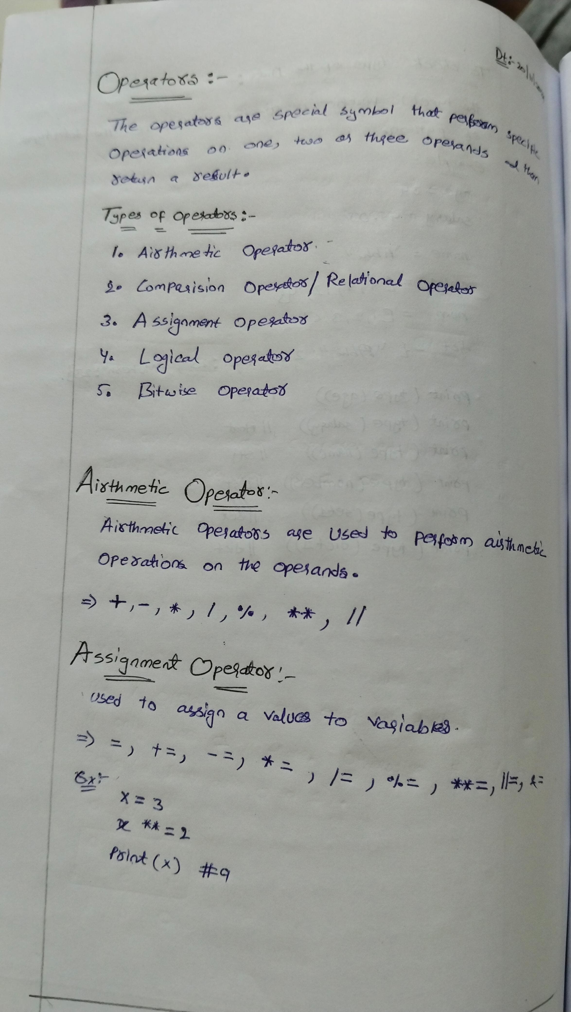

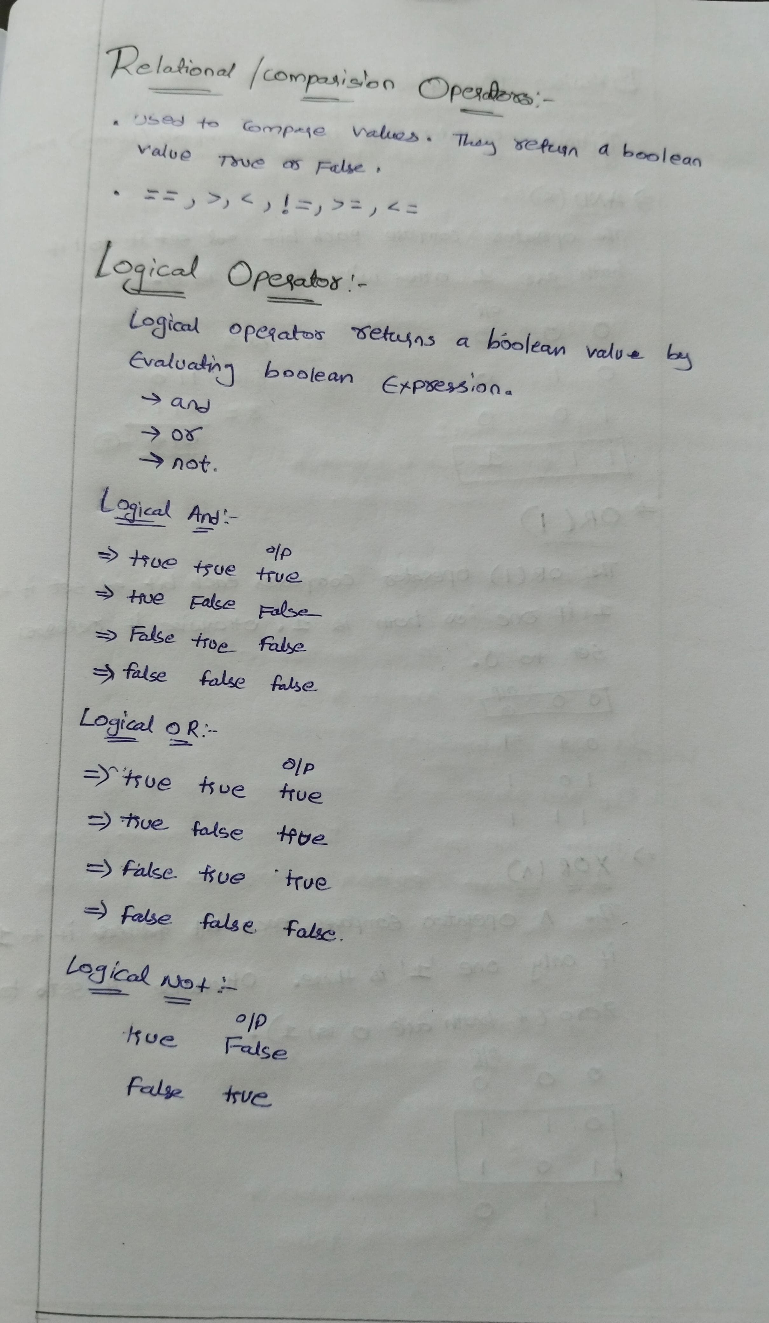

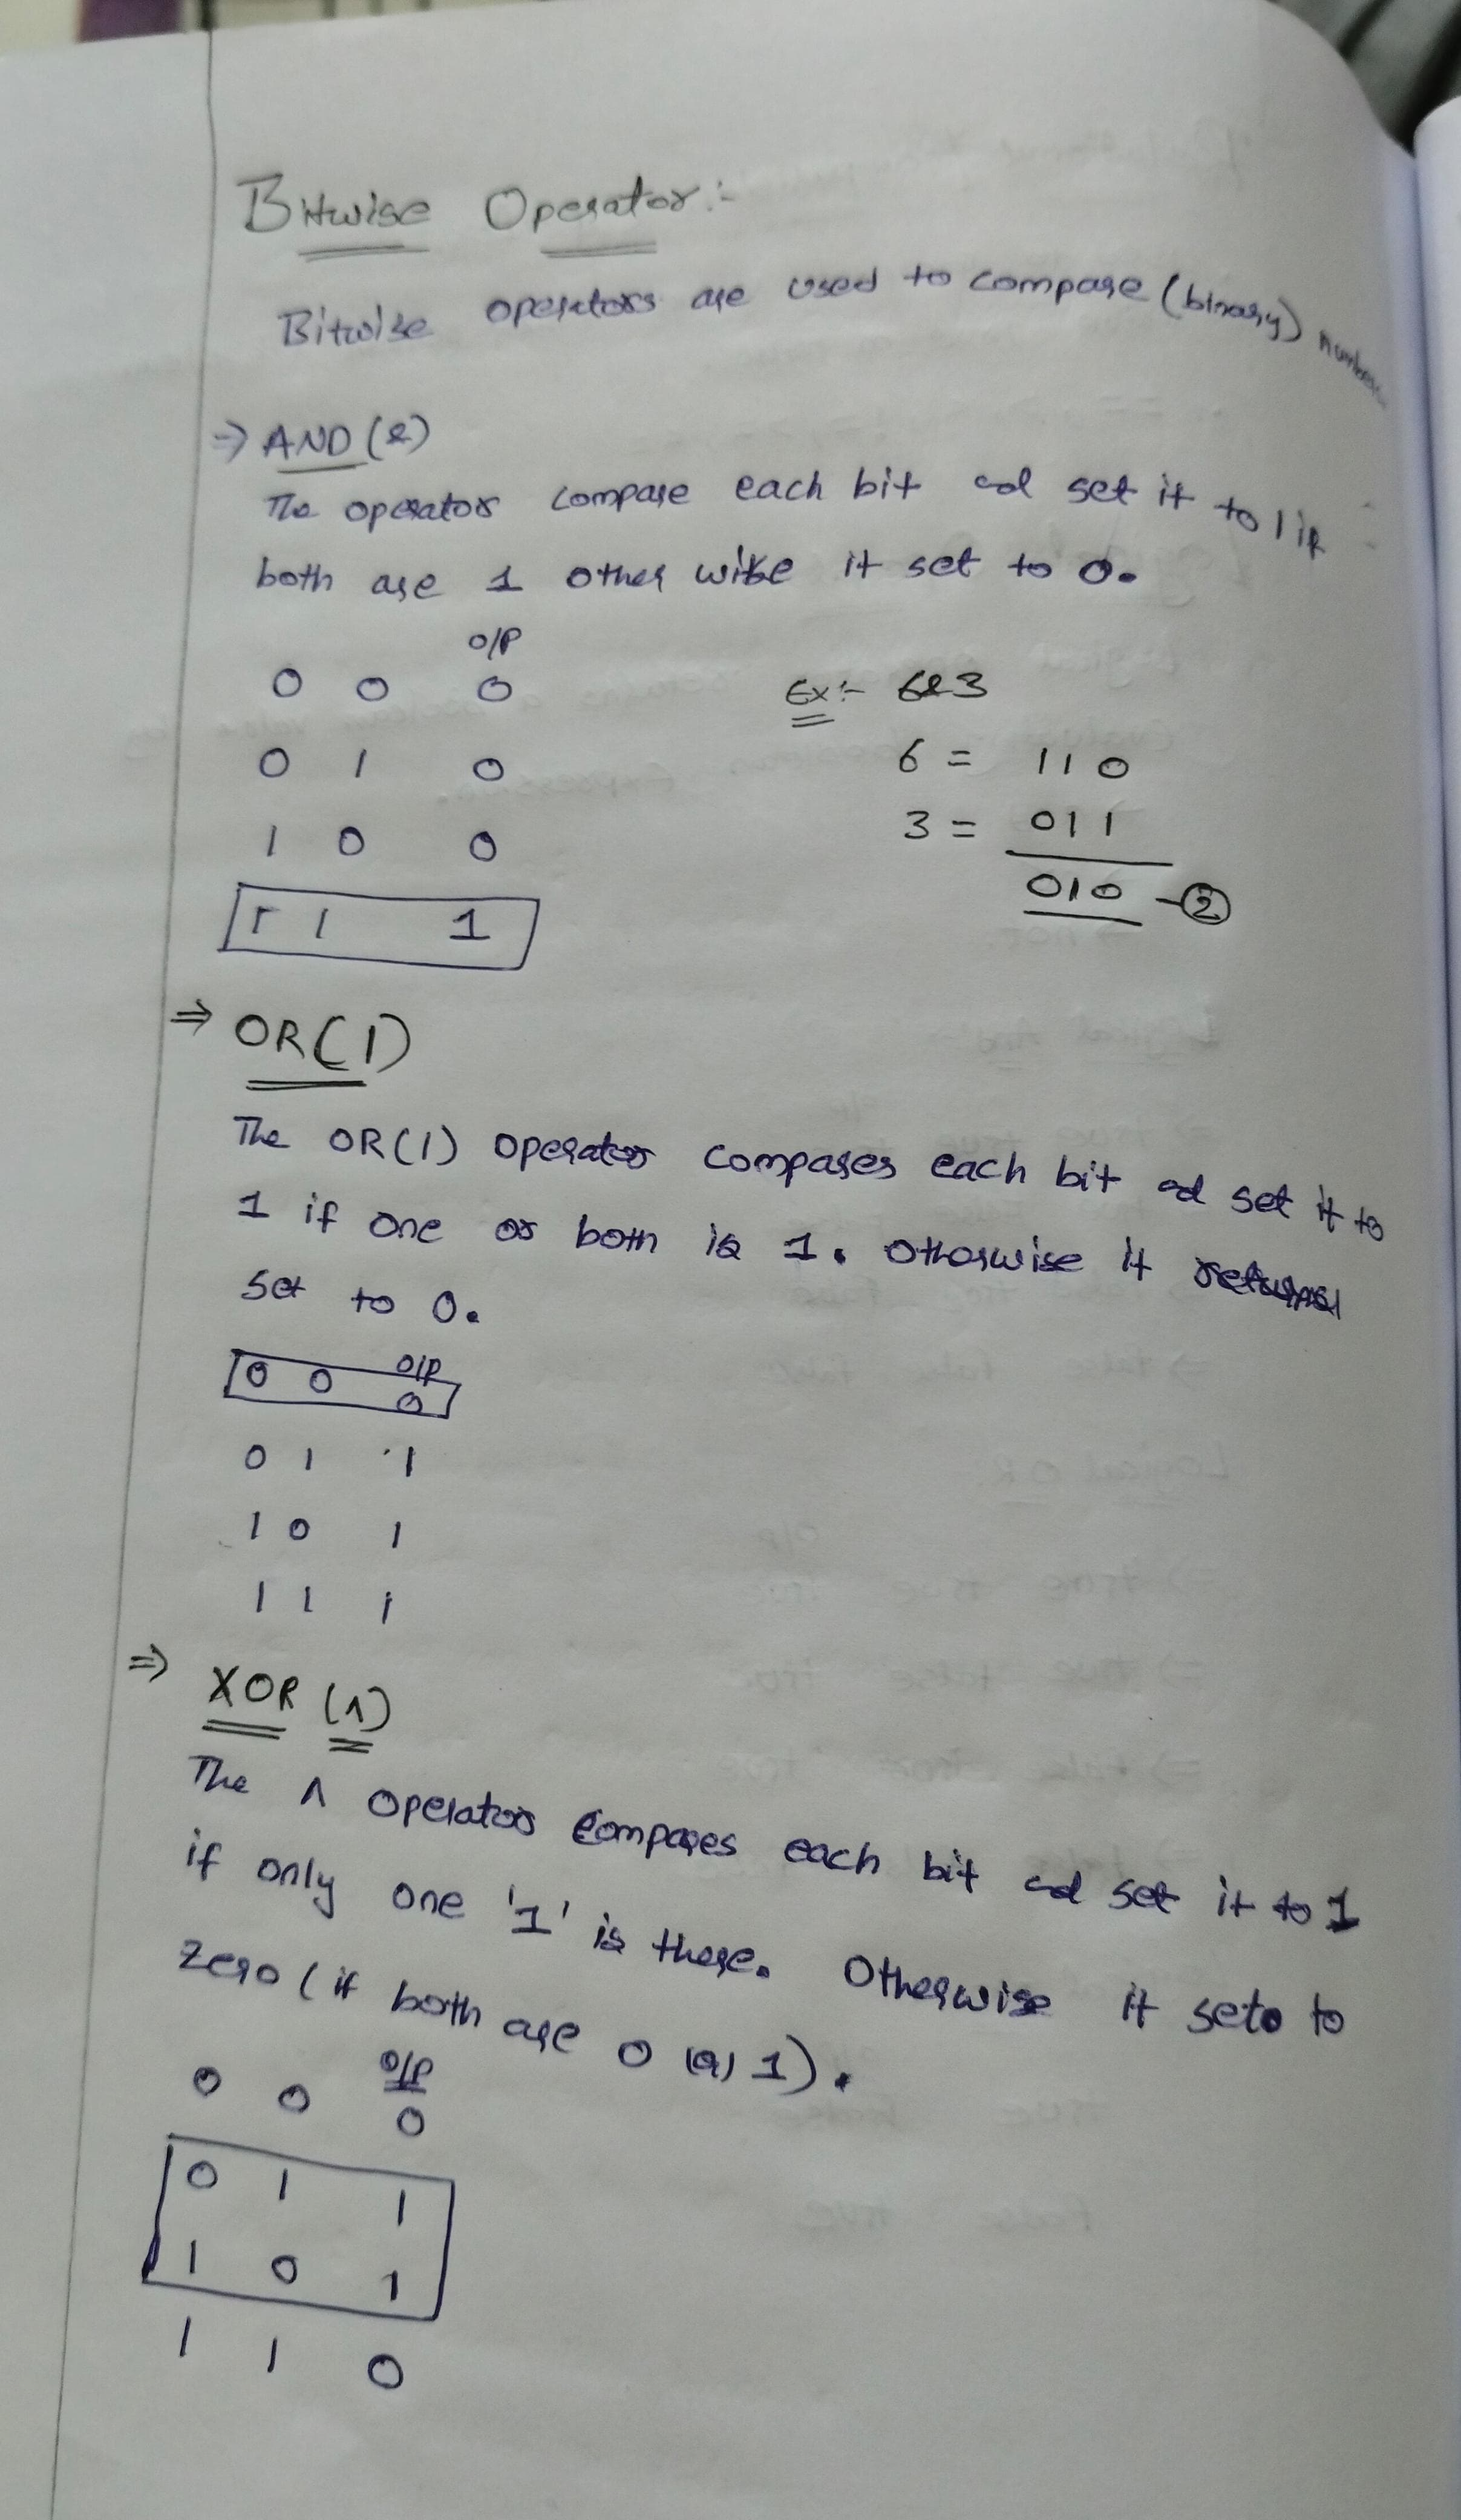

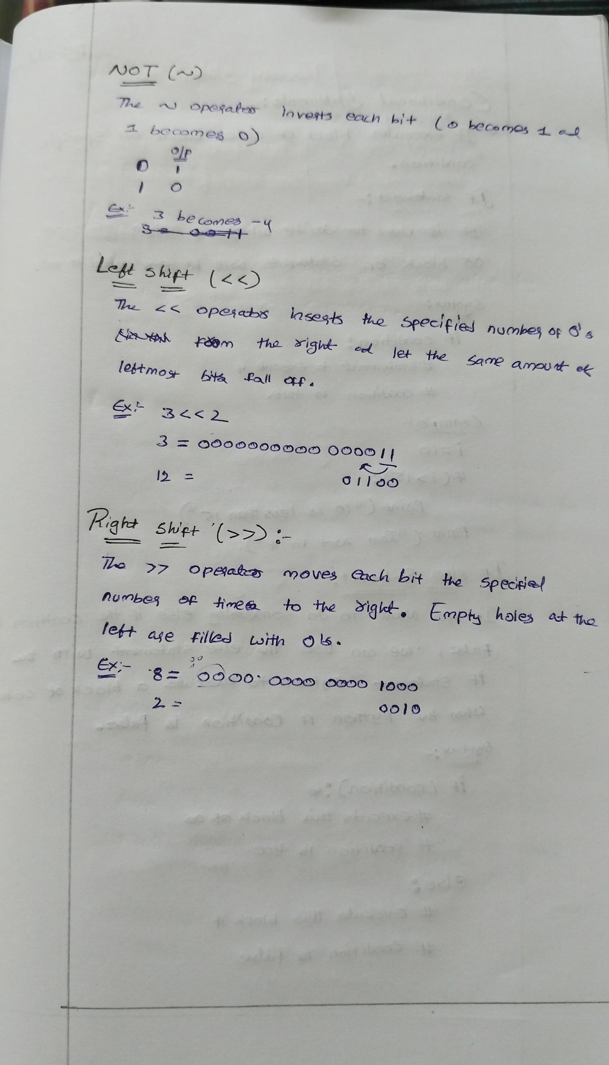

**Conditional statements**

**If Statement:**

The if statement is the most simple decision-making statement. It is used to decide whether a certain statement or block of statements will be executed or not.

**Flowchart of If Statement** Let’s look at the flow of code in the Python If statements

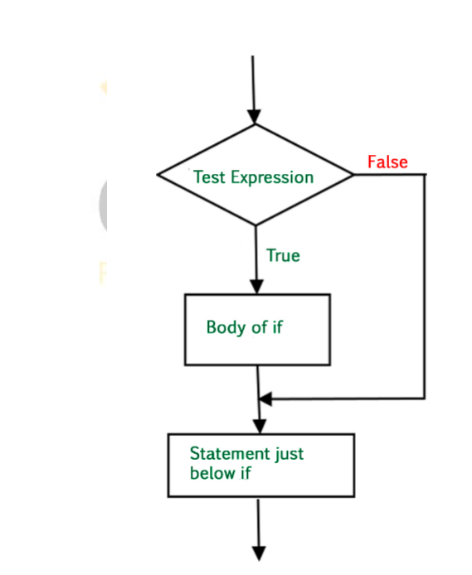

**Syntax of If Statement**:

if condition:  
 # Statements to execute if  
 # condition is true

**Example:**

# if statement example

if 10 > 5:

print("10 greater than 5")

print("Program ended")

**Output:**

10 greater than 5

Program ended

**Python If Else Statement**

The if statement alone tells us that if a condition is true it will execute a block of statements and if the condition is false it won’t. But if we want to do something else if the condition is false, we can use the else statement with the if statement Python to execute a block of code when the Python if condition is false

**Flowchart of If Else Statement** Let’s look at the flow of code in an if else Python statement.

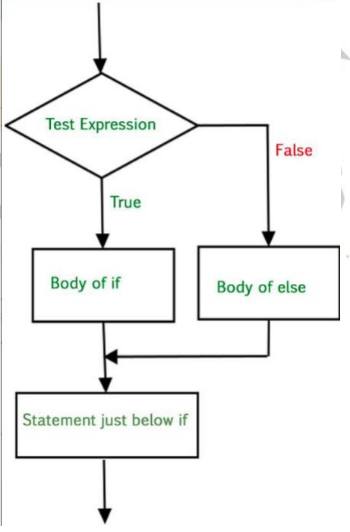

**Syntax of Python If-Else**:

if (condition):  
 # Executes this block if  
 # condition is true  
else:  
 # Executes this block if  
 # condition is false

**Example:**

# if..else statement example

x = 3

if x == 4:

print("Yes")

else:

print("No")

**Output:** No

**Python Nested If Statement**

A nested if is an if statement that is the target of another if statement. Nested if statements mean an if statement inside another if statement.

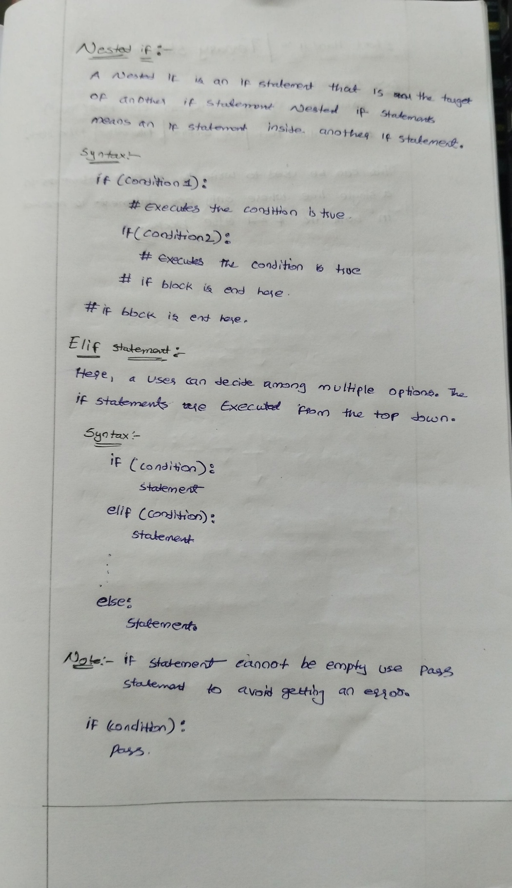

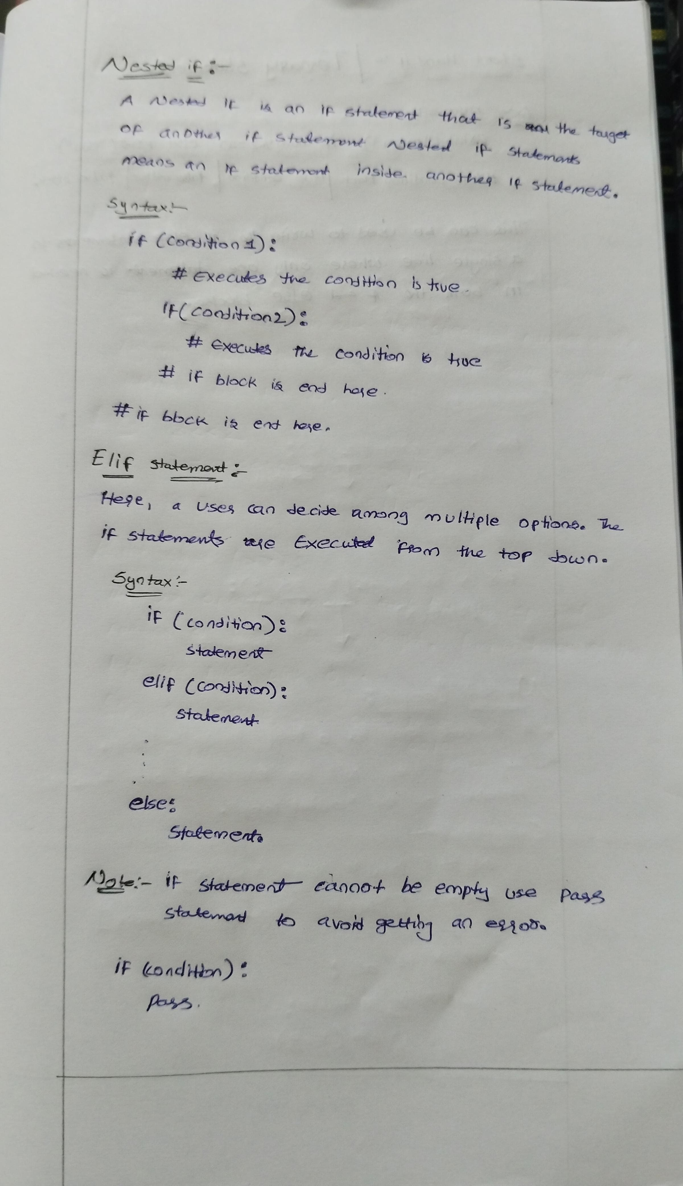

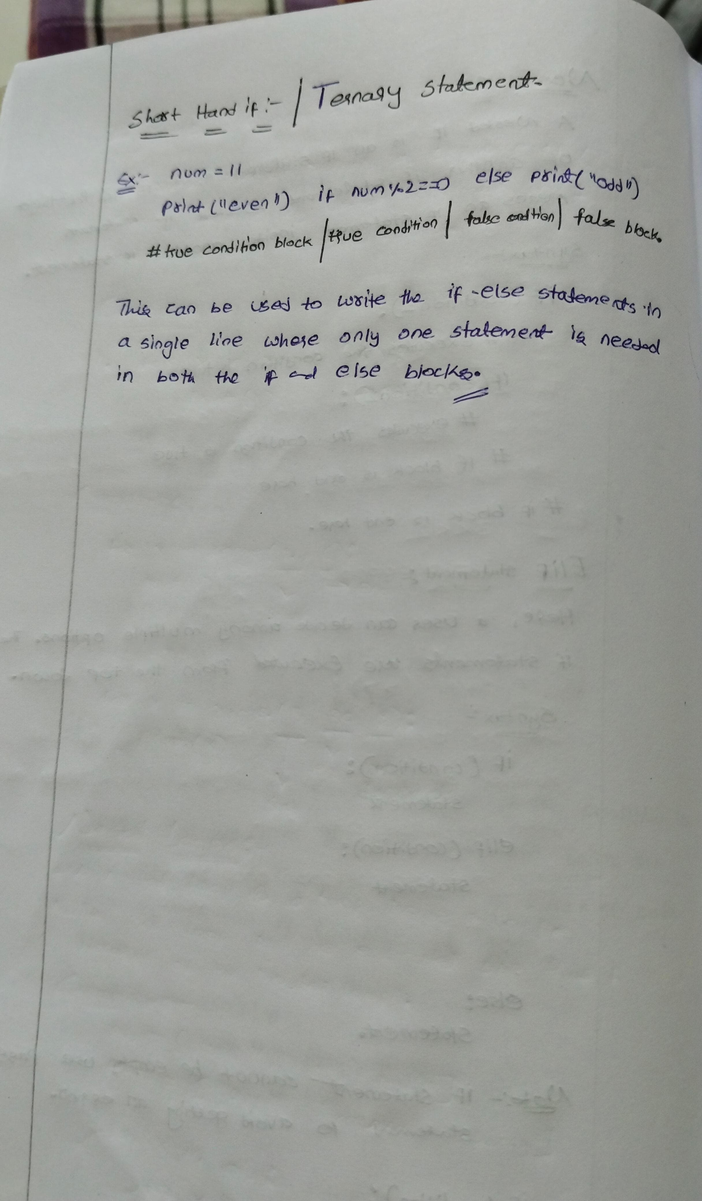

**LOOPS**

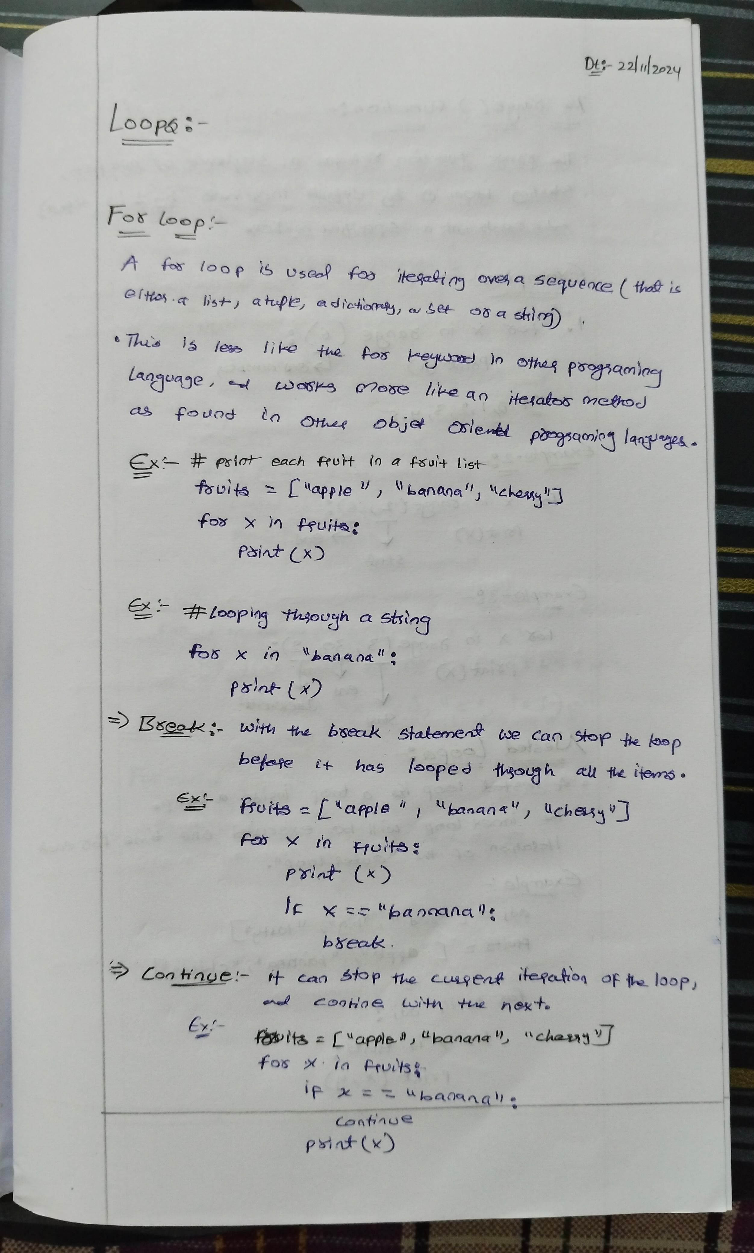

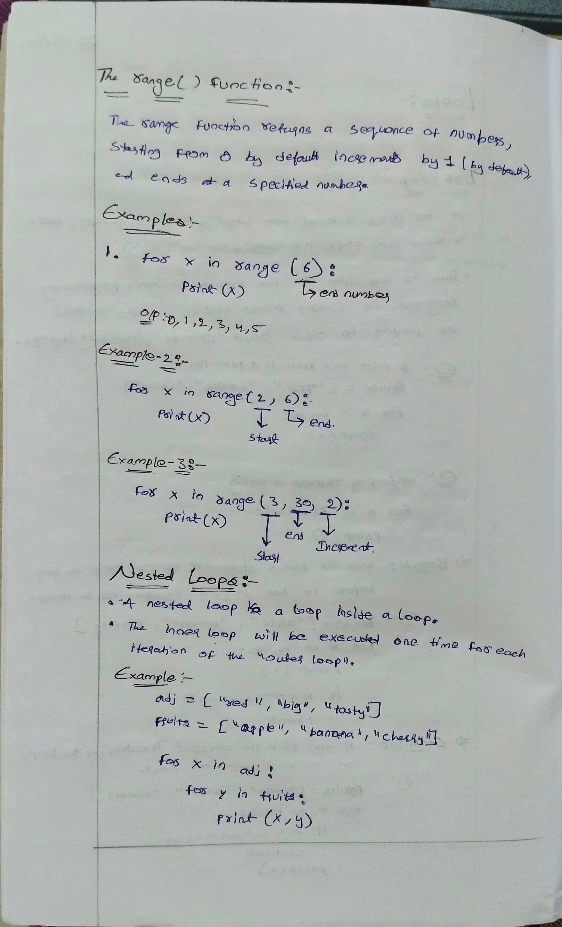

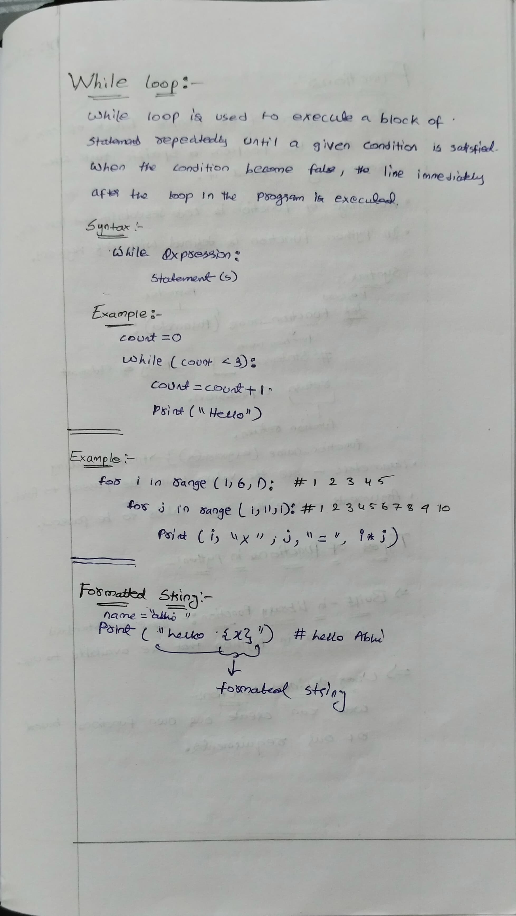

**Functions**

Python Functions

Python Functions is a block of statements that return the specific task. The idea is to put some commonly or repeatedly done tasks together and make a function so that instead of writing the same code again and again for different inputs, we can do the function calls to reuse code contained in it over and over again.

**Some Benefits of Using Functions**

Increase Code Readability

Increase Code Reusability

**Python Function Declaration**

The syntax to declare a function is:

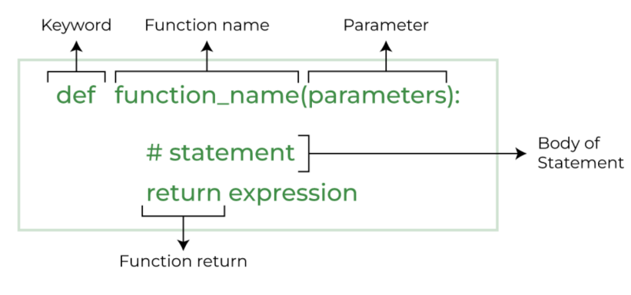

**Types of Functions in Python**

• Below are the different types of functions in Python:

**Built-in library function**: These are Standard functions in Python that are available to use.

**User-defined function**: We can create our own functions based on our requirements.

**Creating a Function in Python**

We can define a function in Python, using the def keyword. We can add any type of functionalities and properties to it as we require. By the following example, we can understand how to write a function in Python. In this way we can create Python function definition by using def keyword.

**Syntax:**

# A simple Python function

def fun():

print("Welcome to GFG")

**Calling a Function in Python**

After creating a function in Python we can call it by using the name of the functions Python followed by parenthesis containing parameters of that particular function. Below is the example for calling def function Python.

**Example:**

# A simple Python function

def fun():

print("Welcome to GFG")

# Driver code to call a function

fun()

**Python Function Arguments**

Arguments are the values passed inside the parenthesis of the function. A function can have any number of arguments separated by a comma.

In this example, we will create a simple function in Python to check whether the number passed as an argument to the function is even or odd.

**Example:**

# A simple Python function to check

# whether x is even or odd

def evenOdd(x):

if (x % 2 == 0):

print("even")

else:

print("odd")

# Driver code to call the function

evenOdd(2)

evenOdd(3)

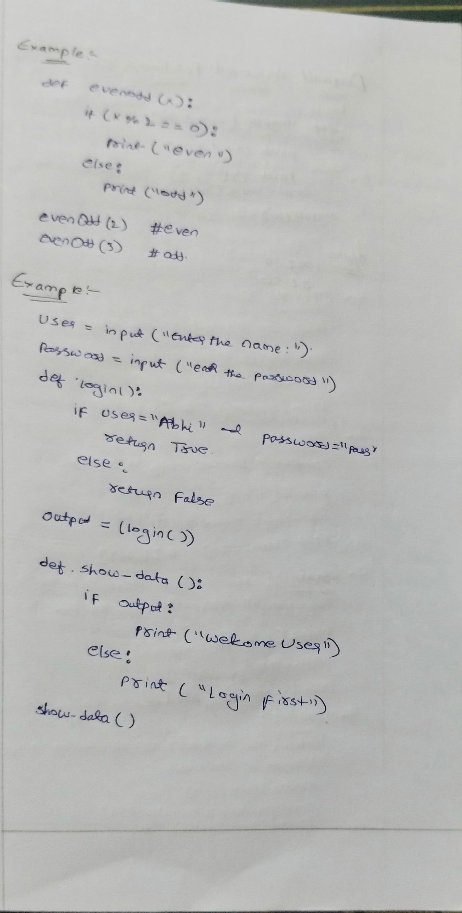

**Python Default arguments**

A default argument is a parameter that assumes a default value if a value is not provided in the function call for that argument. The following example illustrates Default arguments.

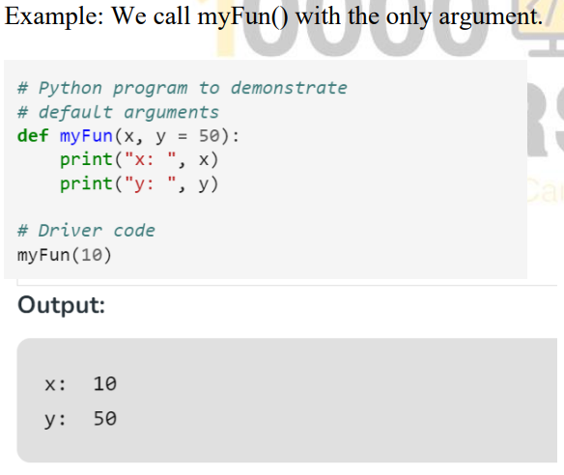

**Taking input in Python**

**input ()** function first takes the input from the user and converts it into a string. The type of the returned object always will be <class ‘str’>. It does not evaluate the expression it just returns the complete statement as String.

**Example-1:**

# Python program showing

# a use of input()

val = input("Enter your value: ")

print(val)

**Example-2:**

username = input("Enter username:")

print("Username is: " + username)

**List Methods**

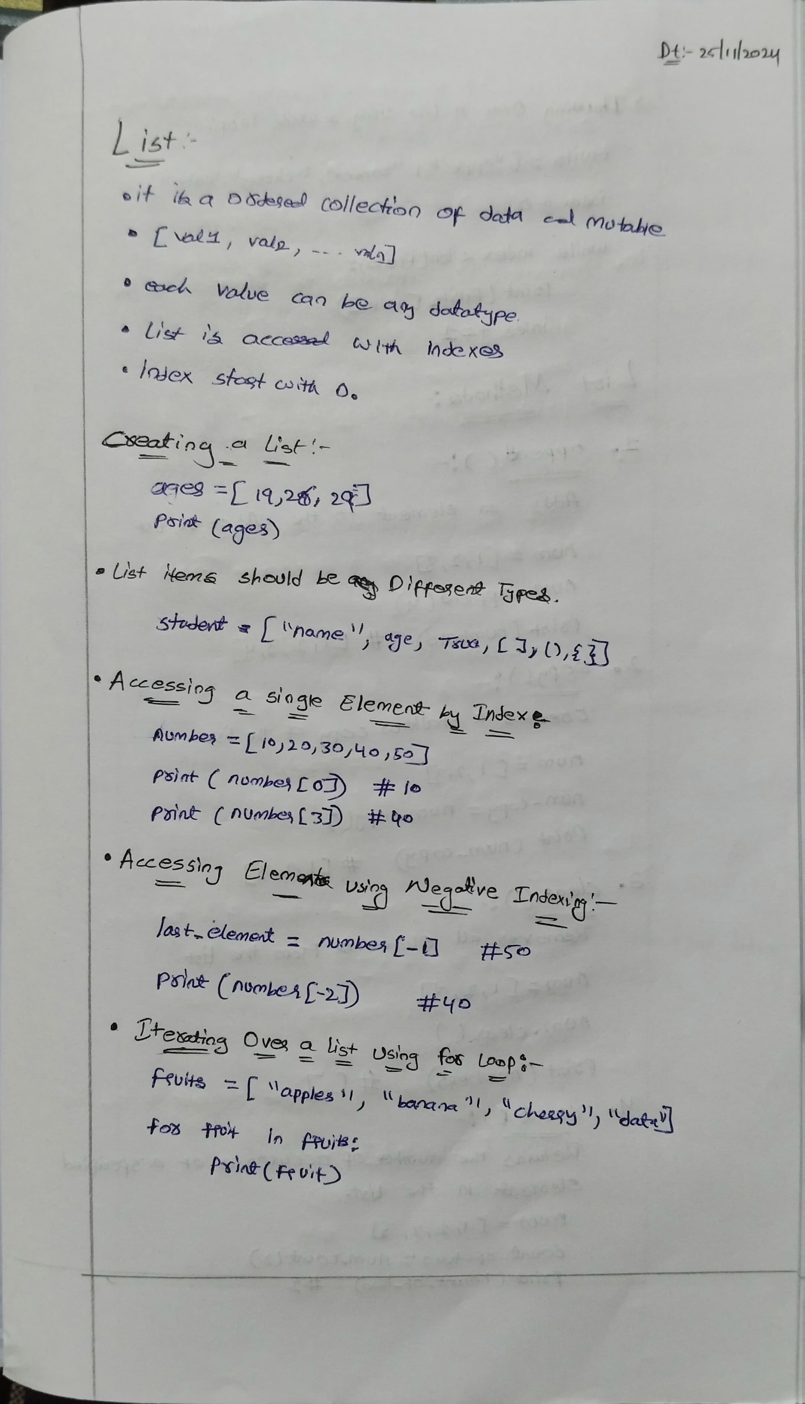

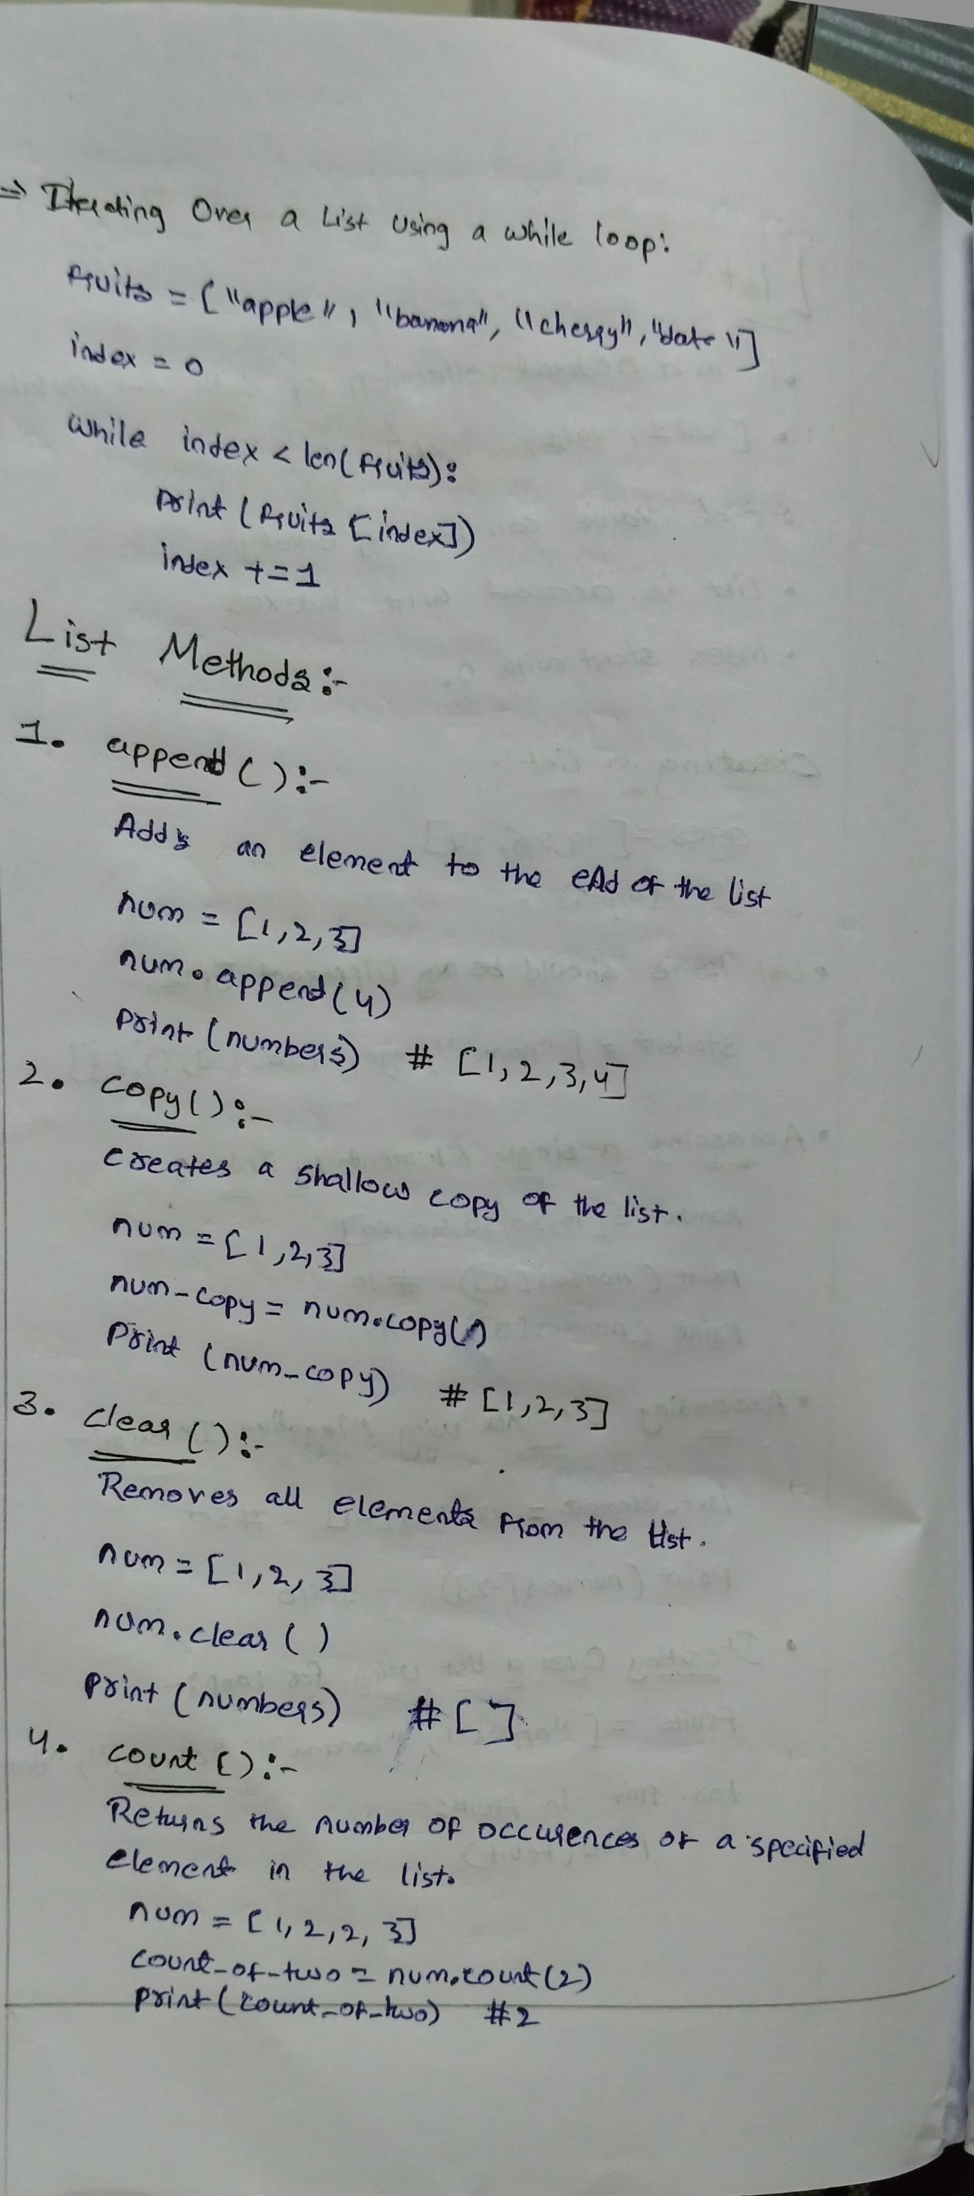



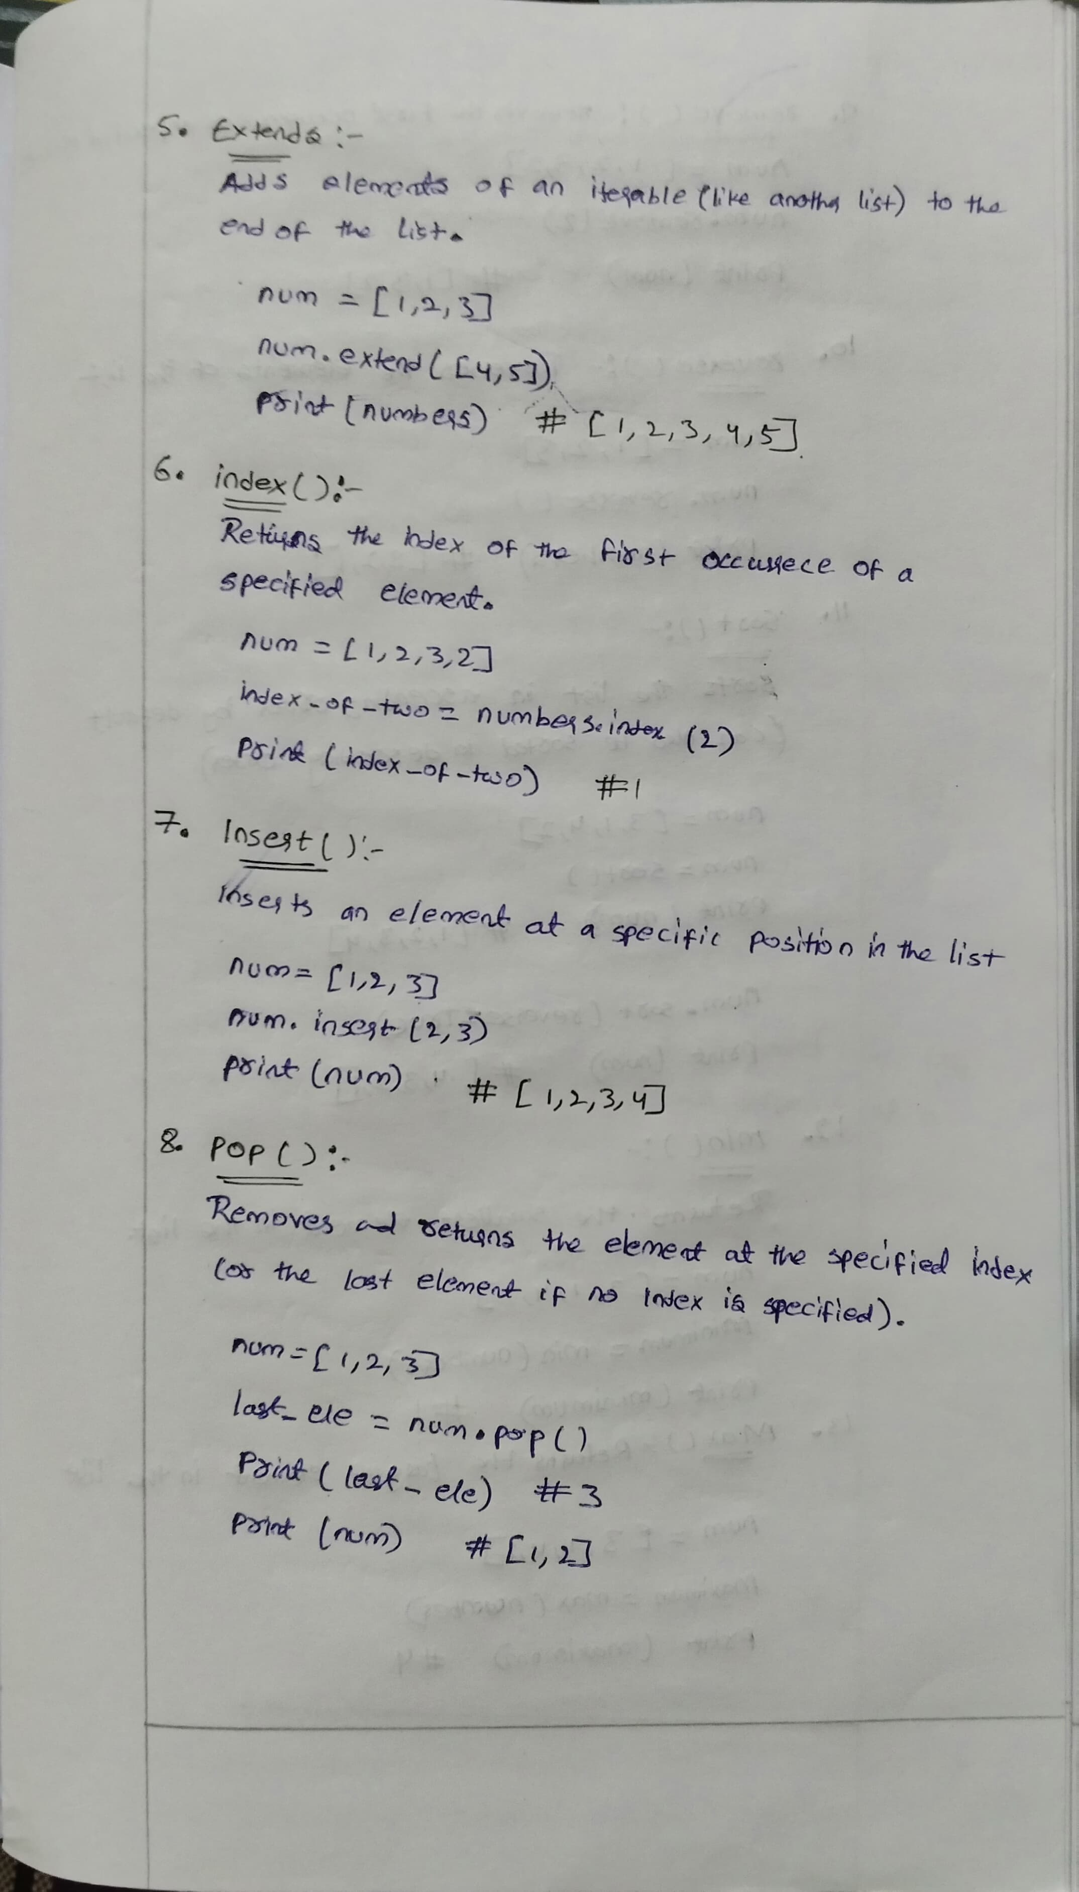



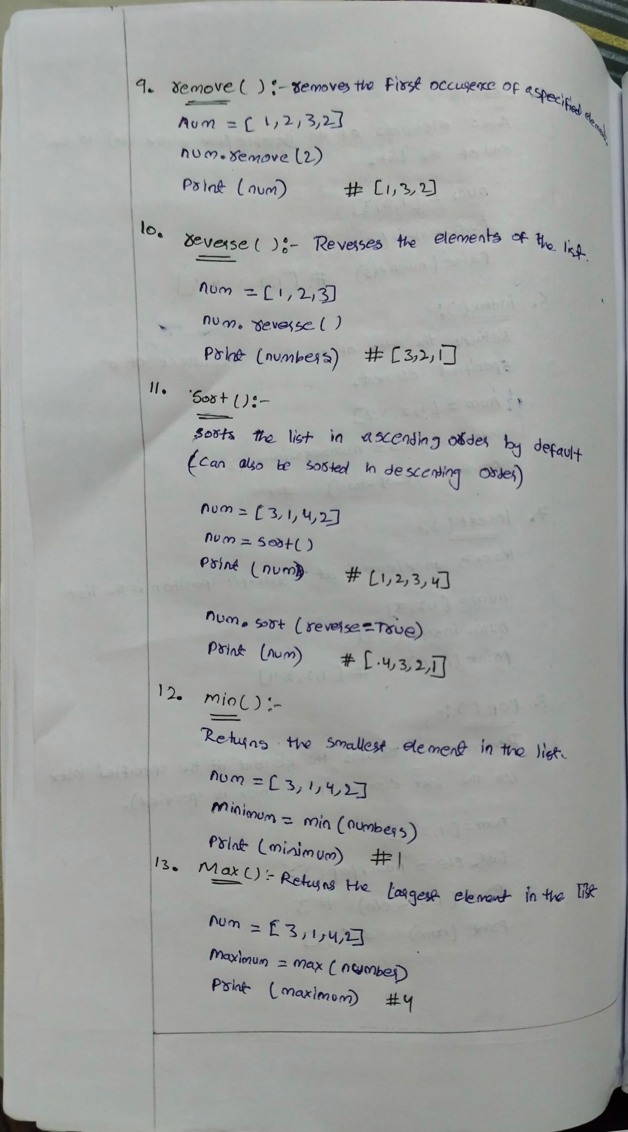

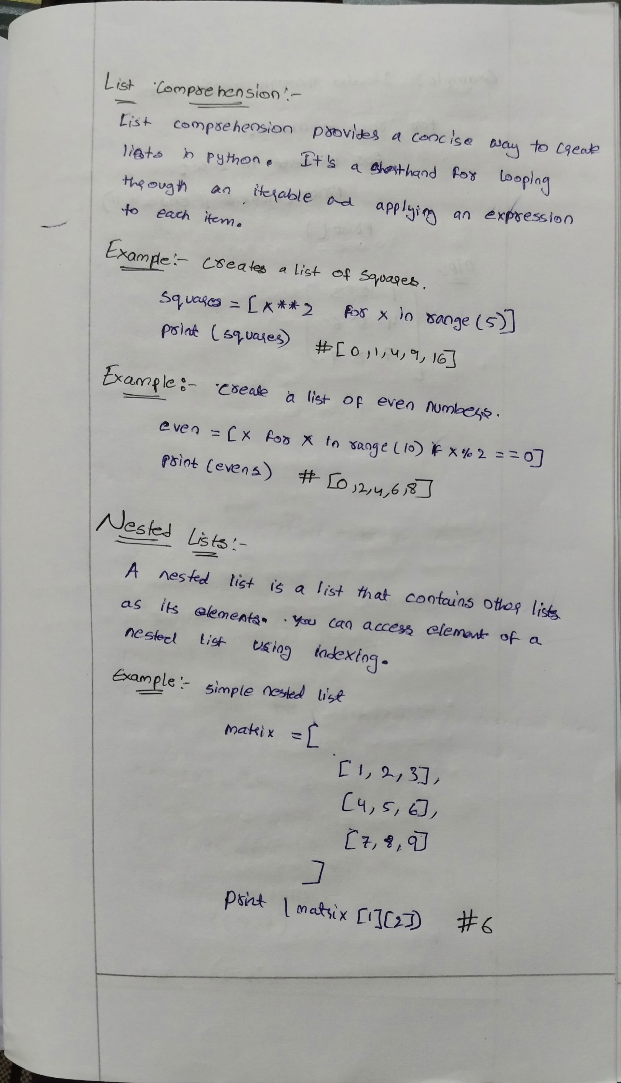

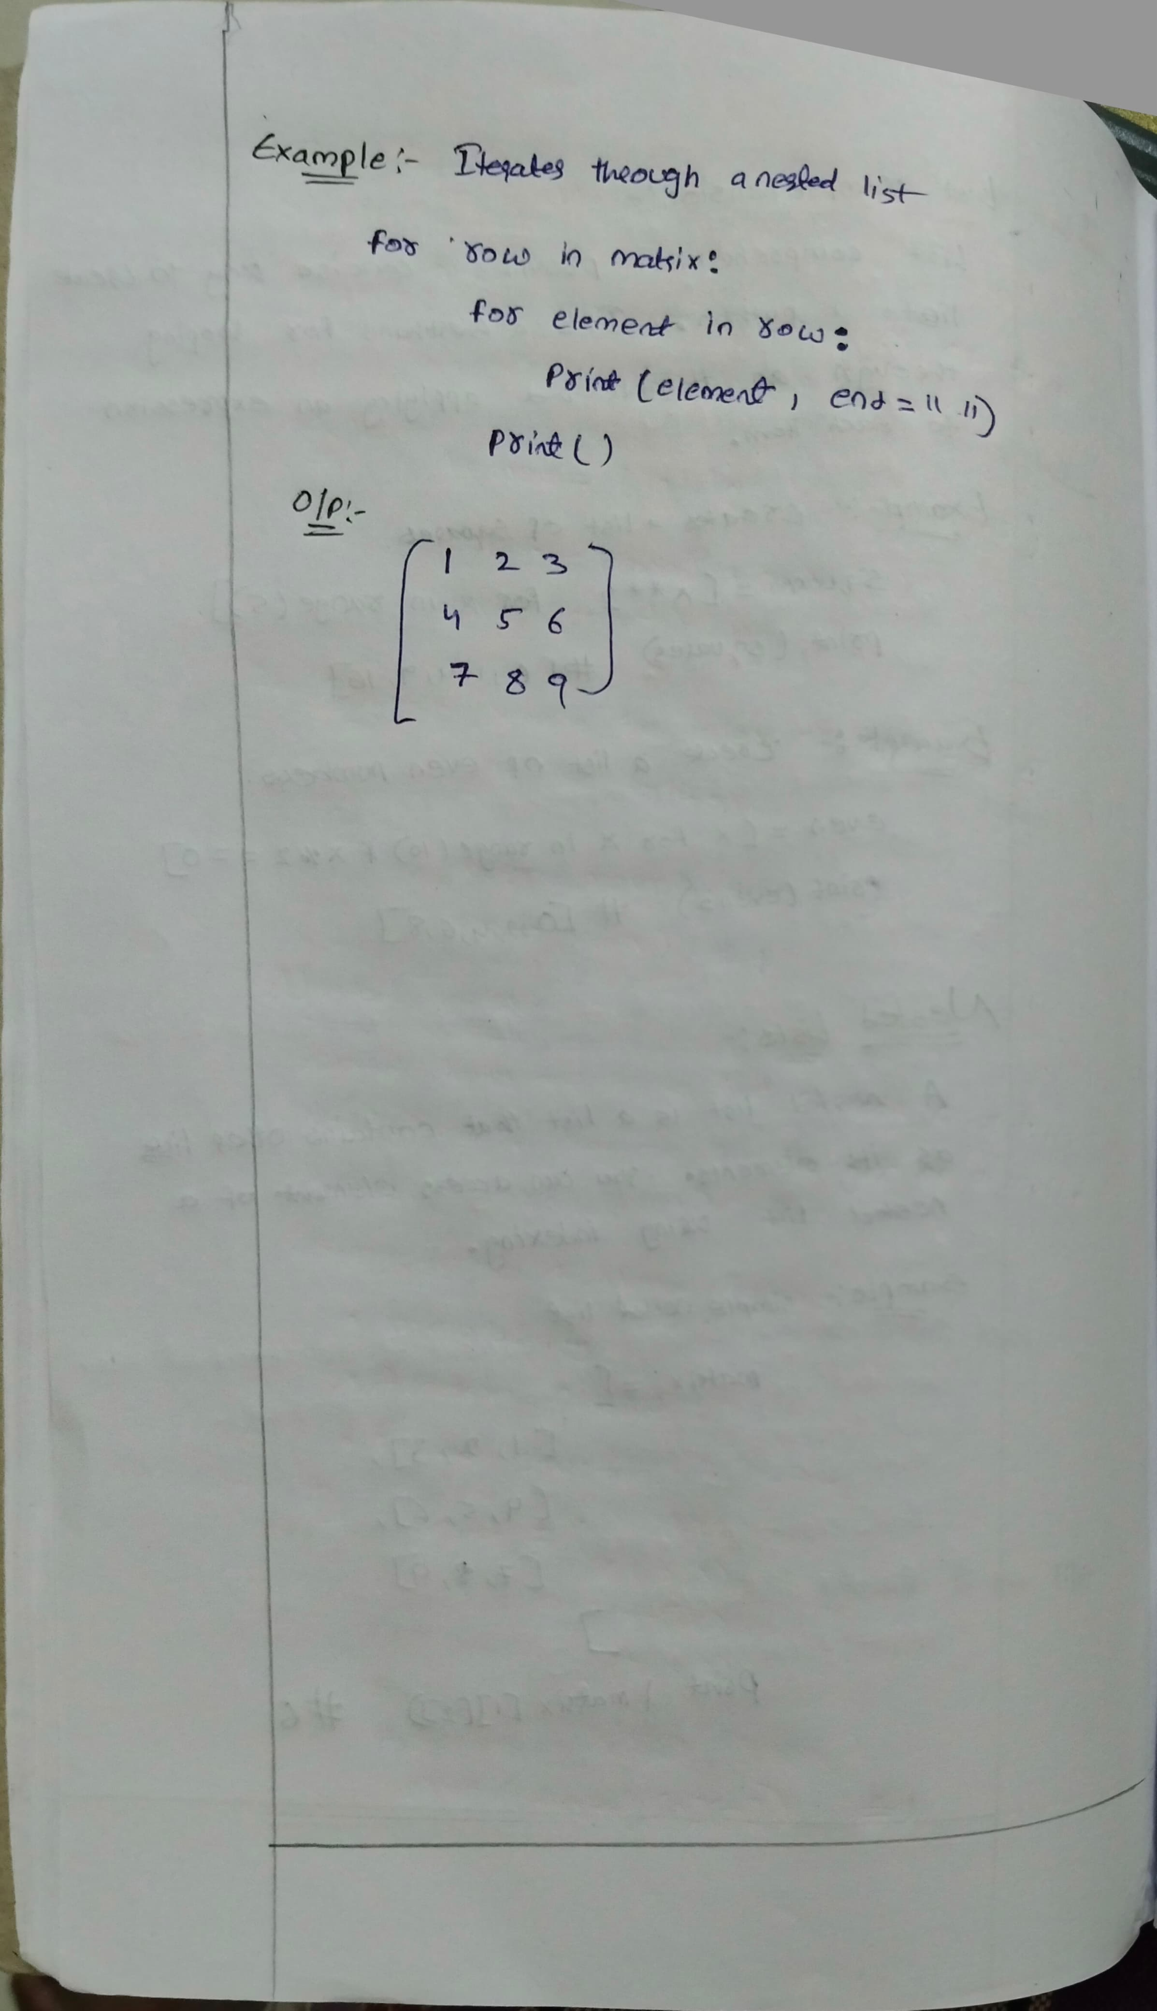

**Tuple methods**

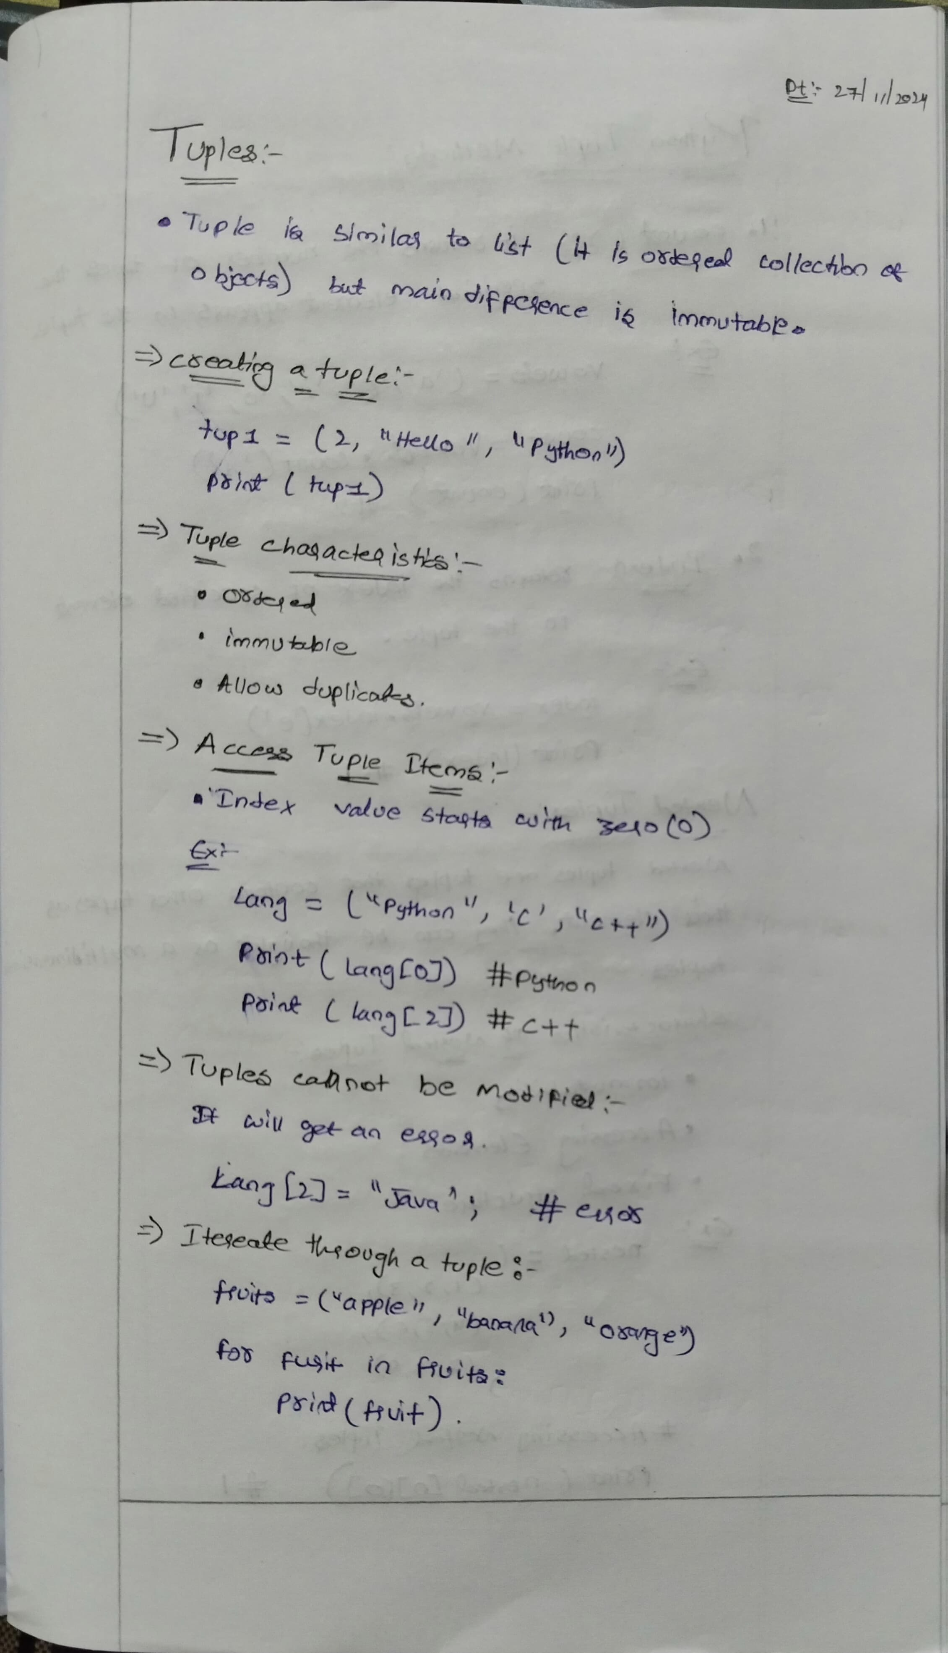

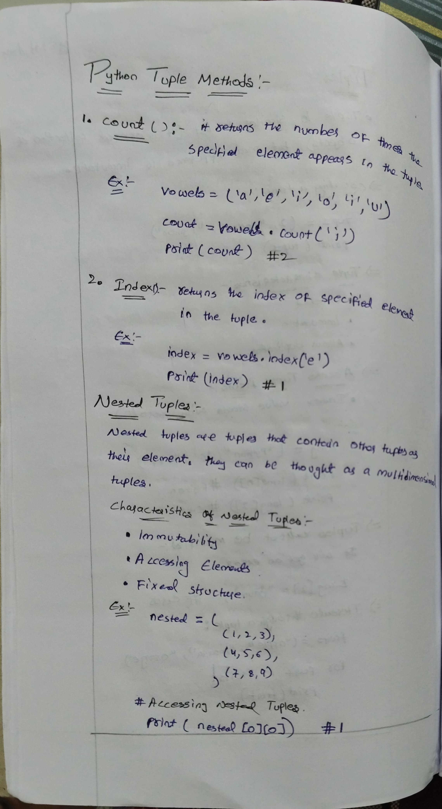

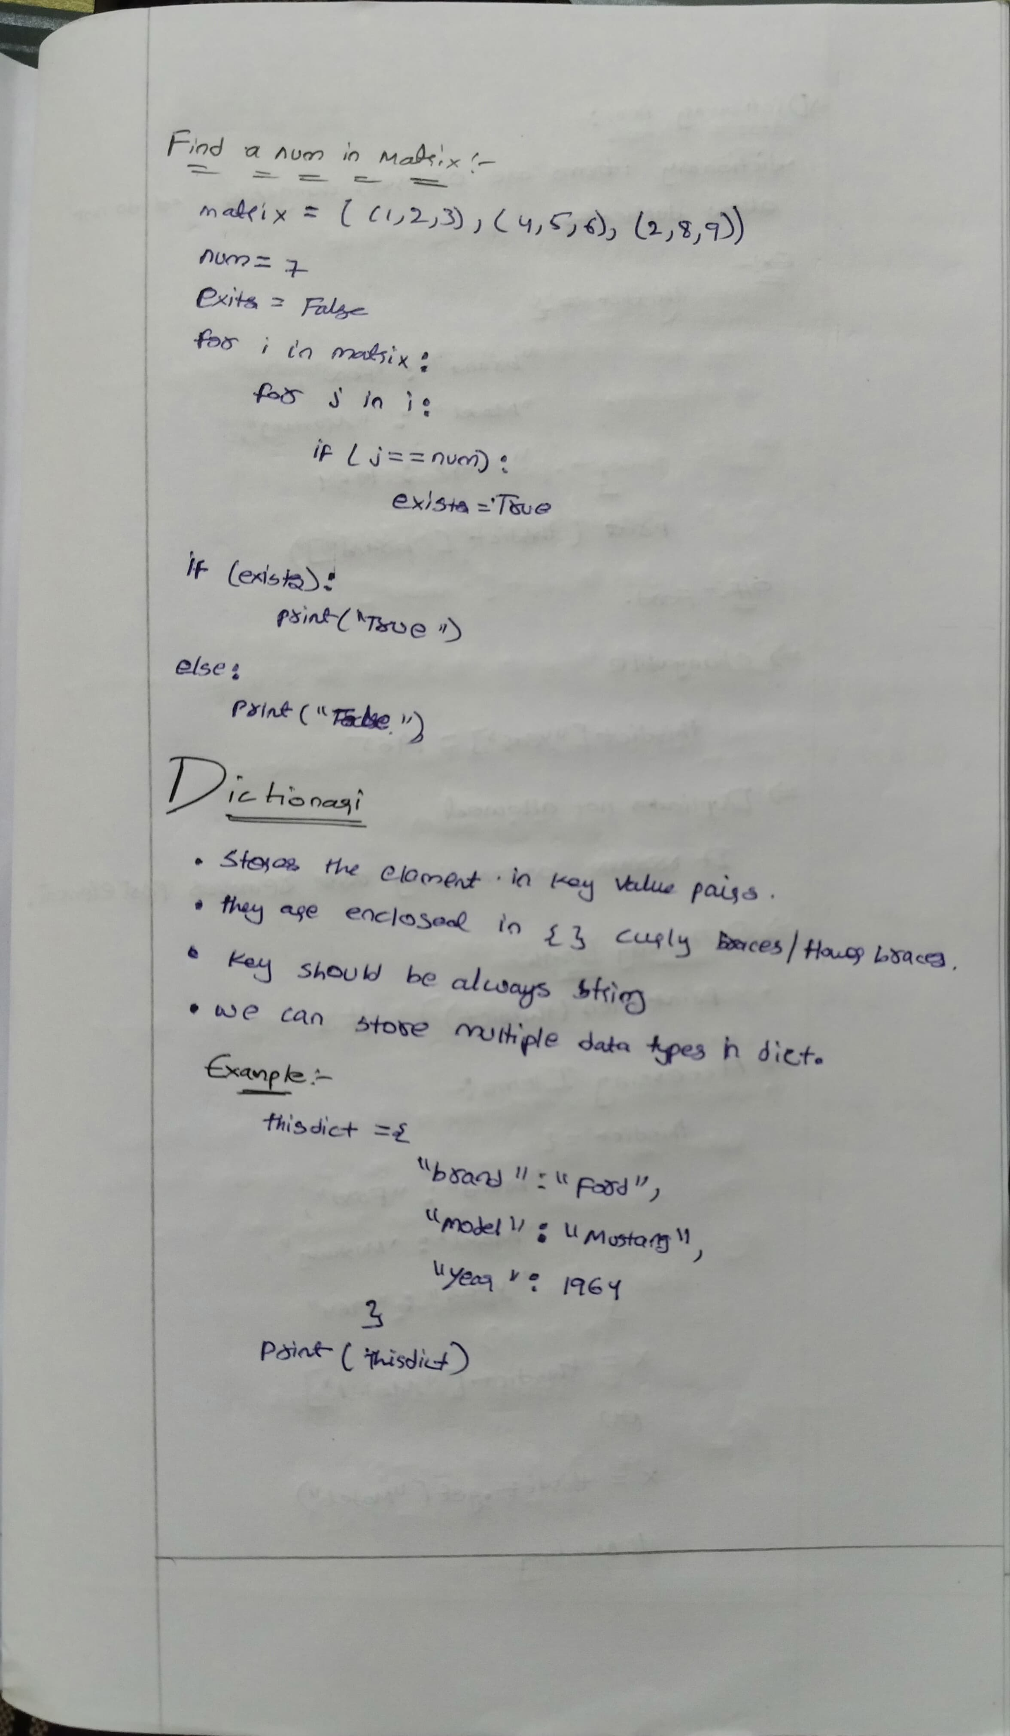

**Dictionary Methods**



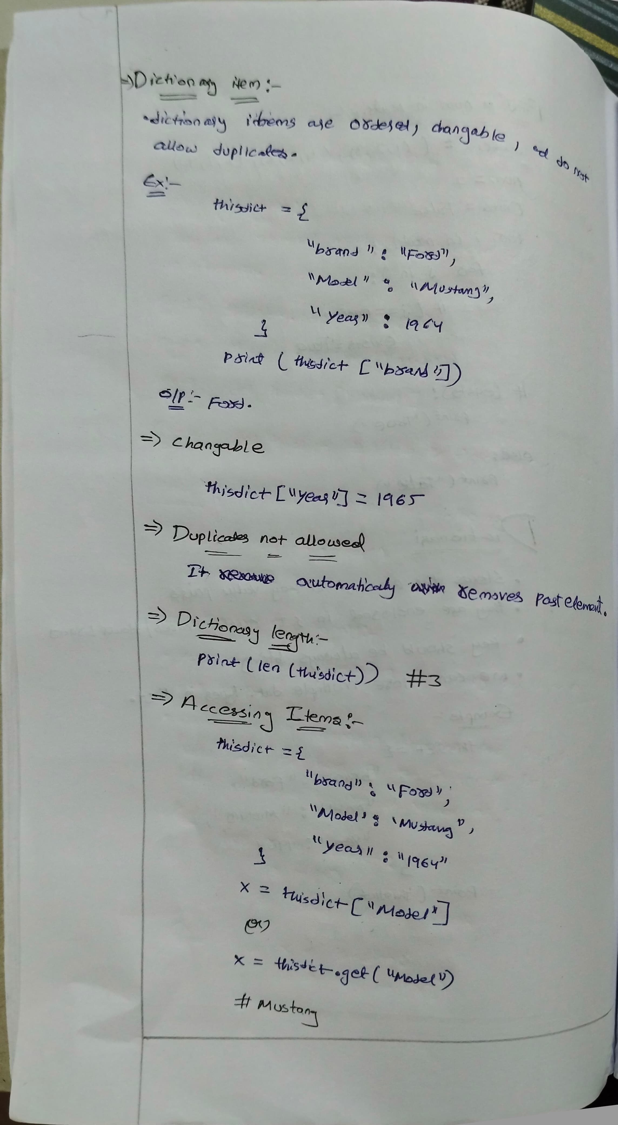

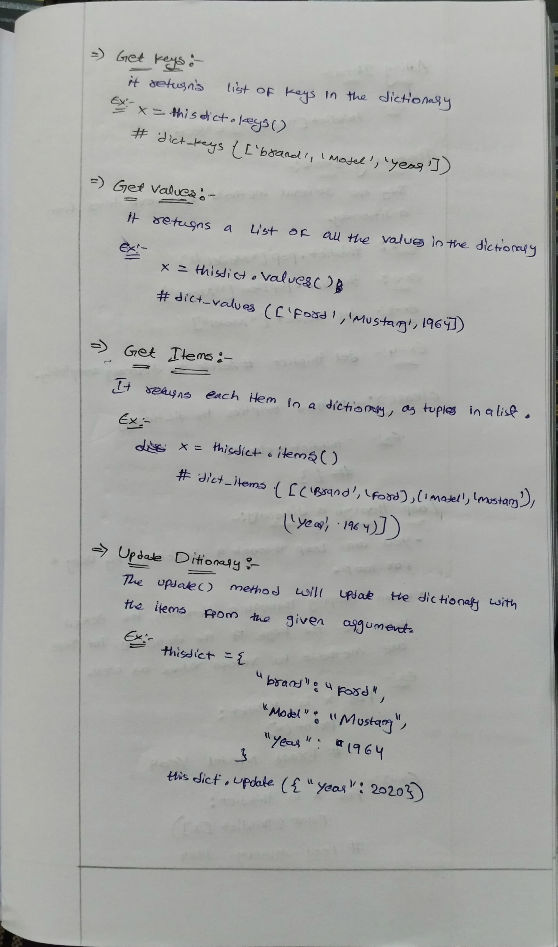

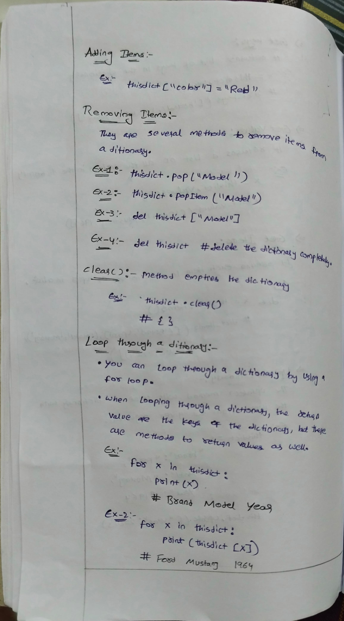

**String and string methods:**

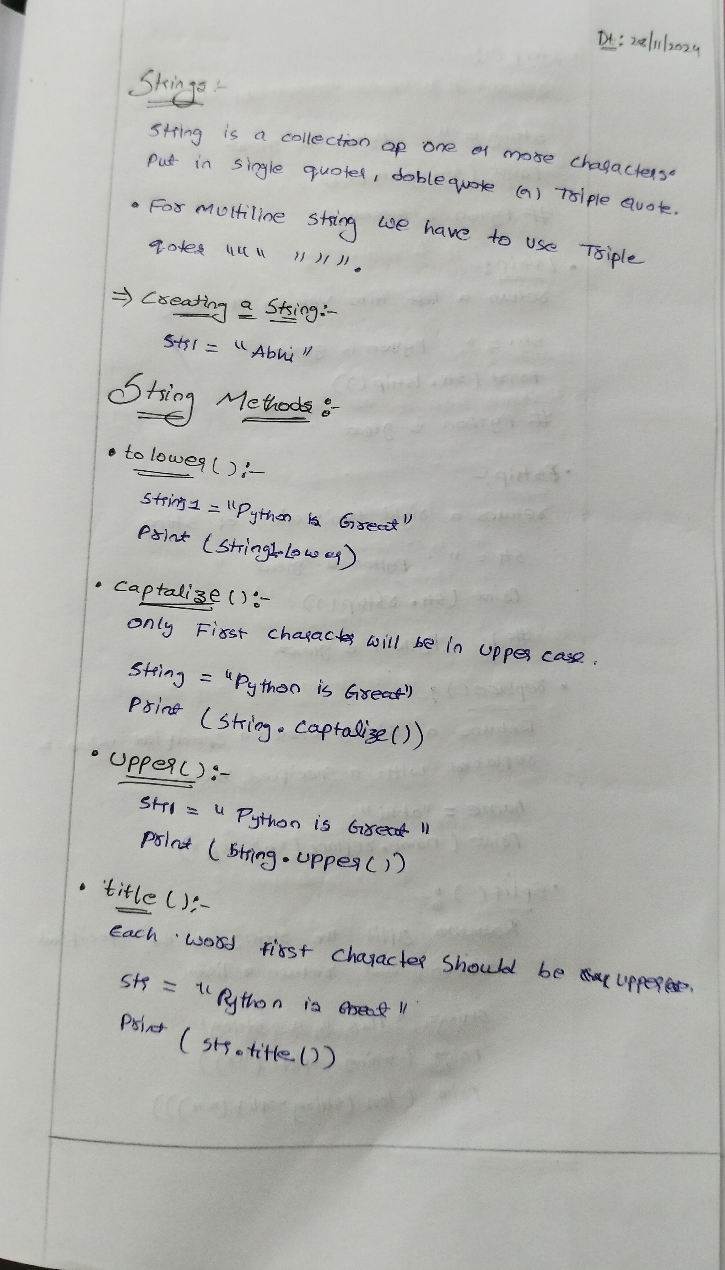

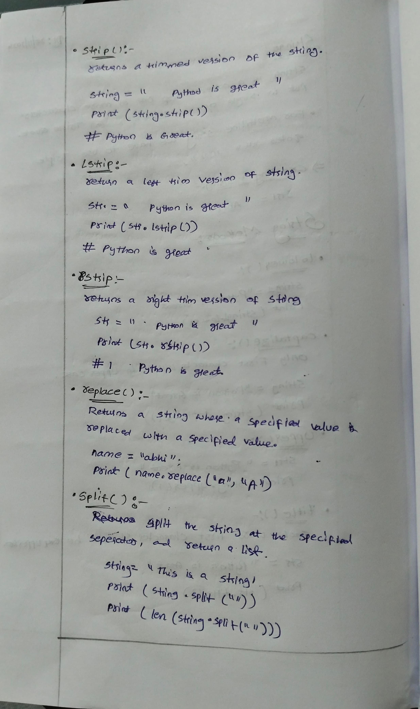

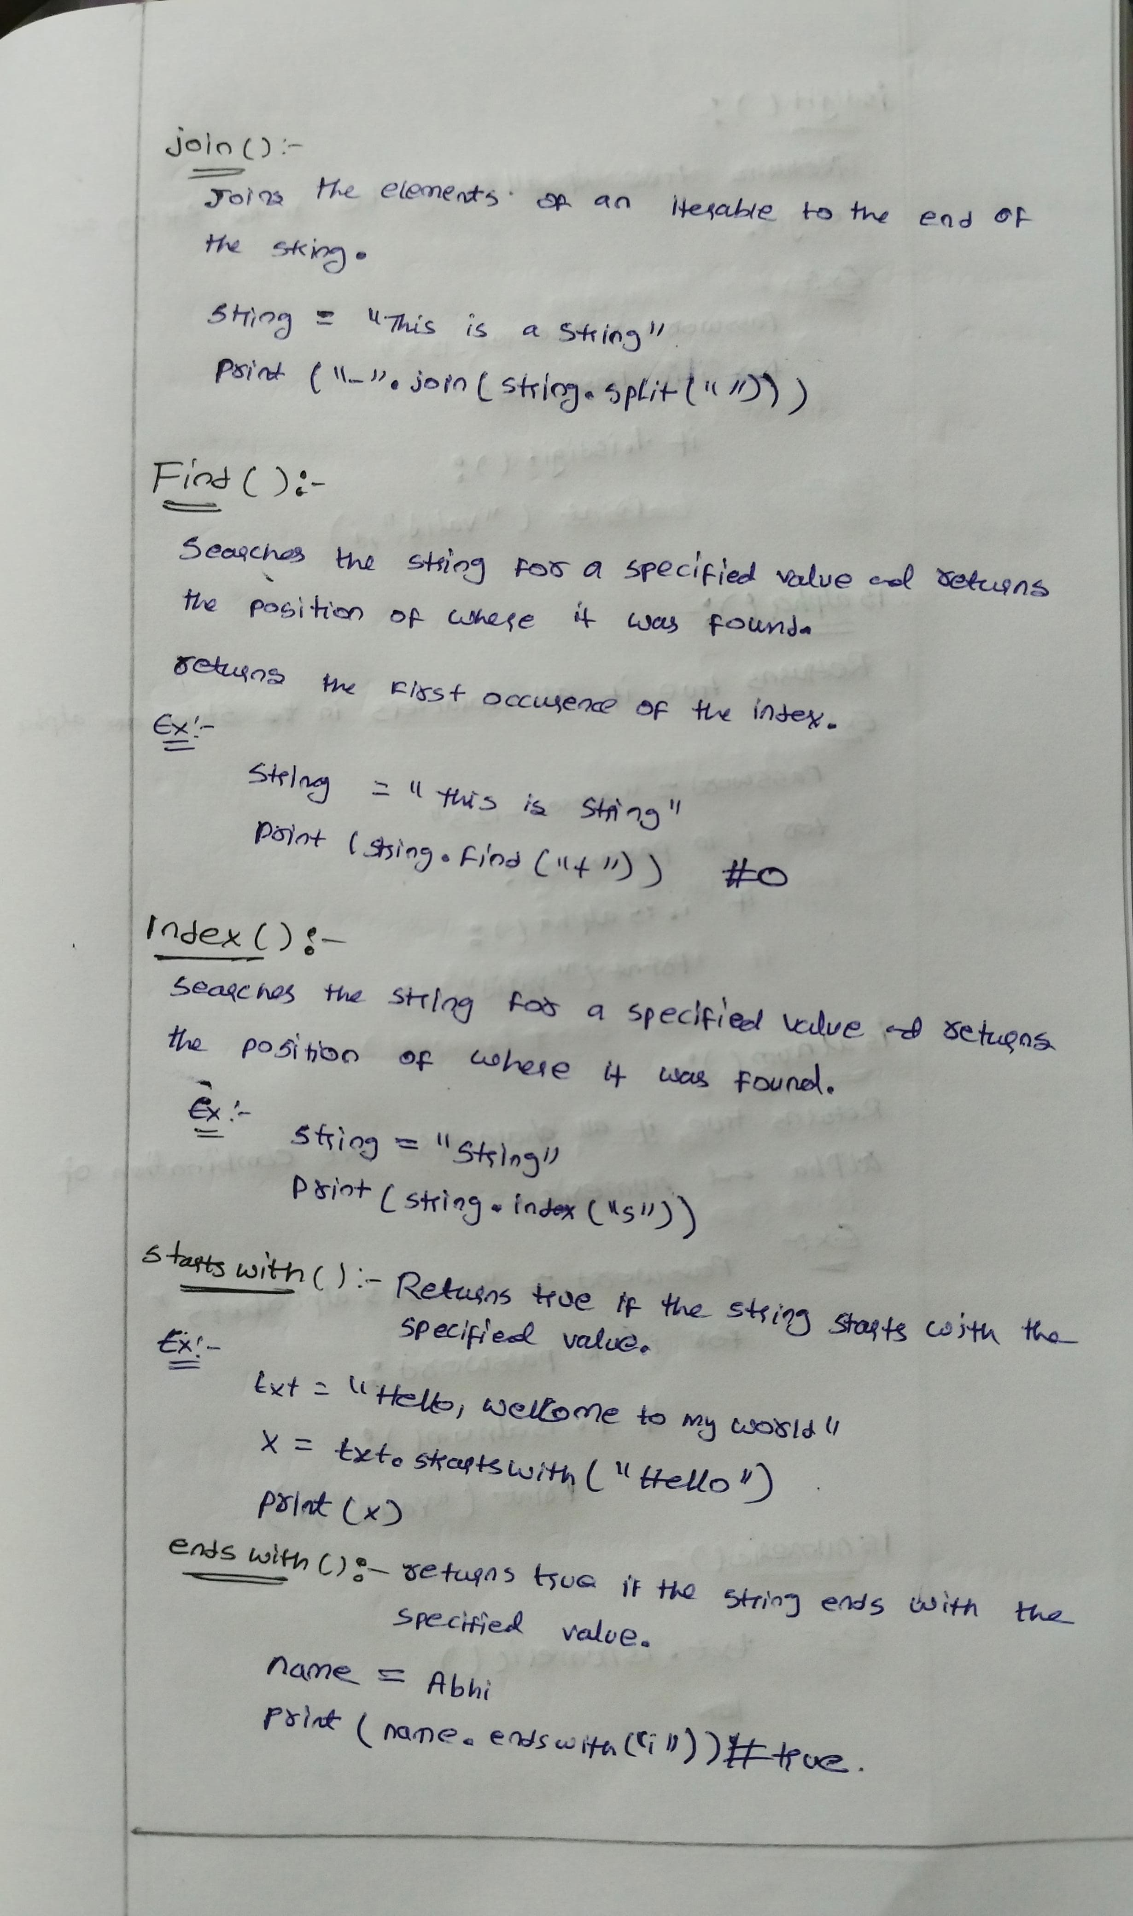

The isalpha() method returns True if all the characters are alphabet letters (a-z).

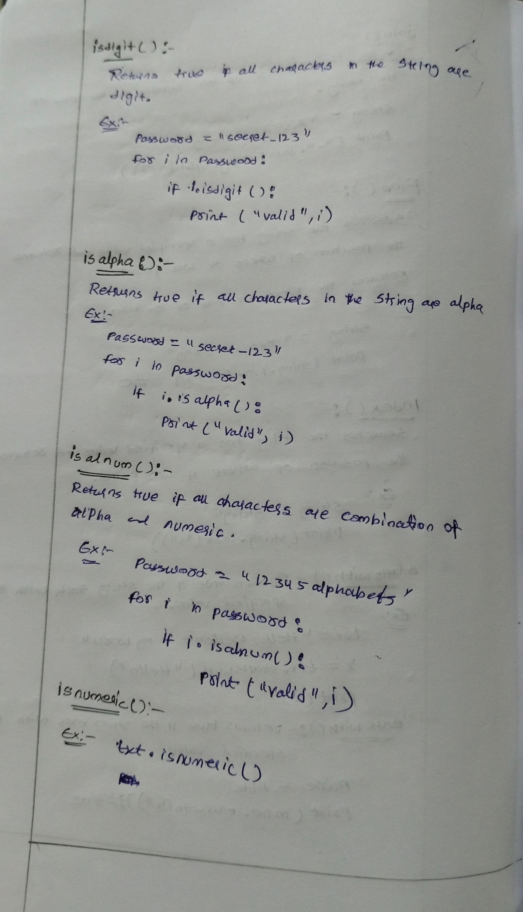

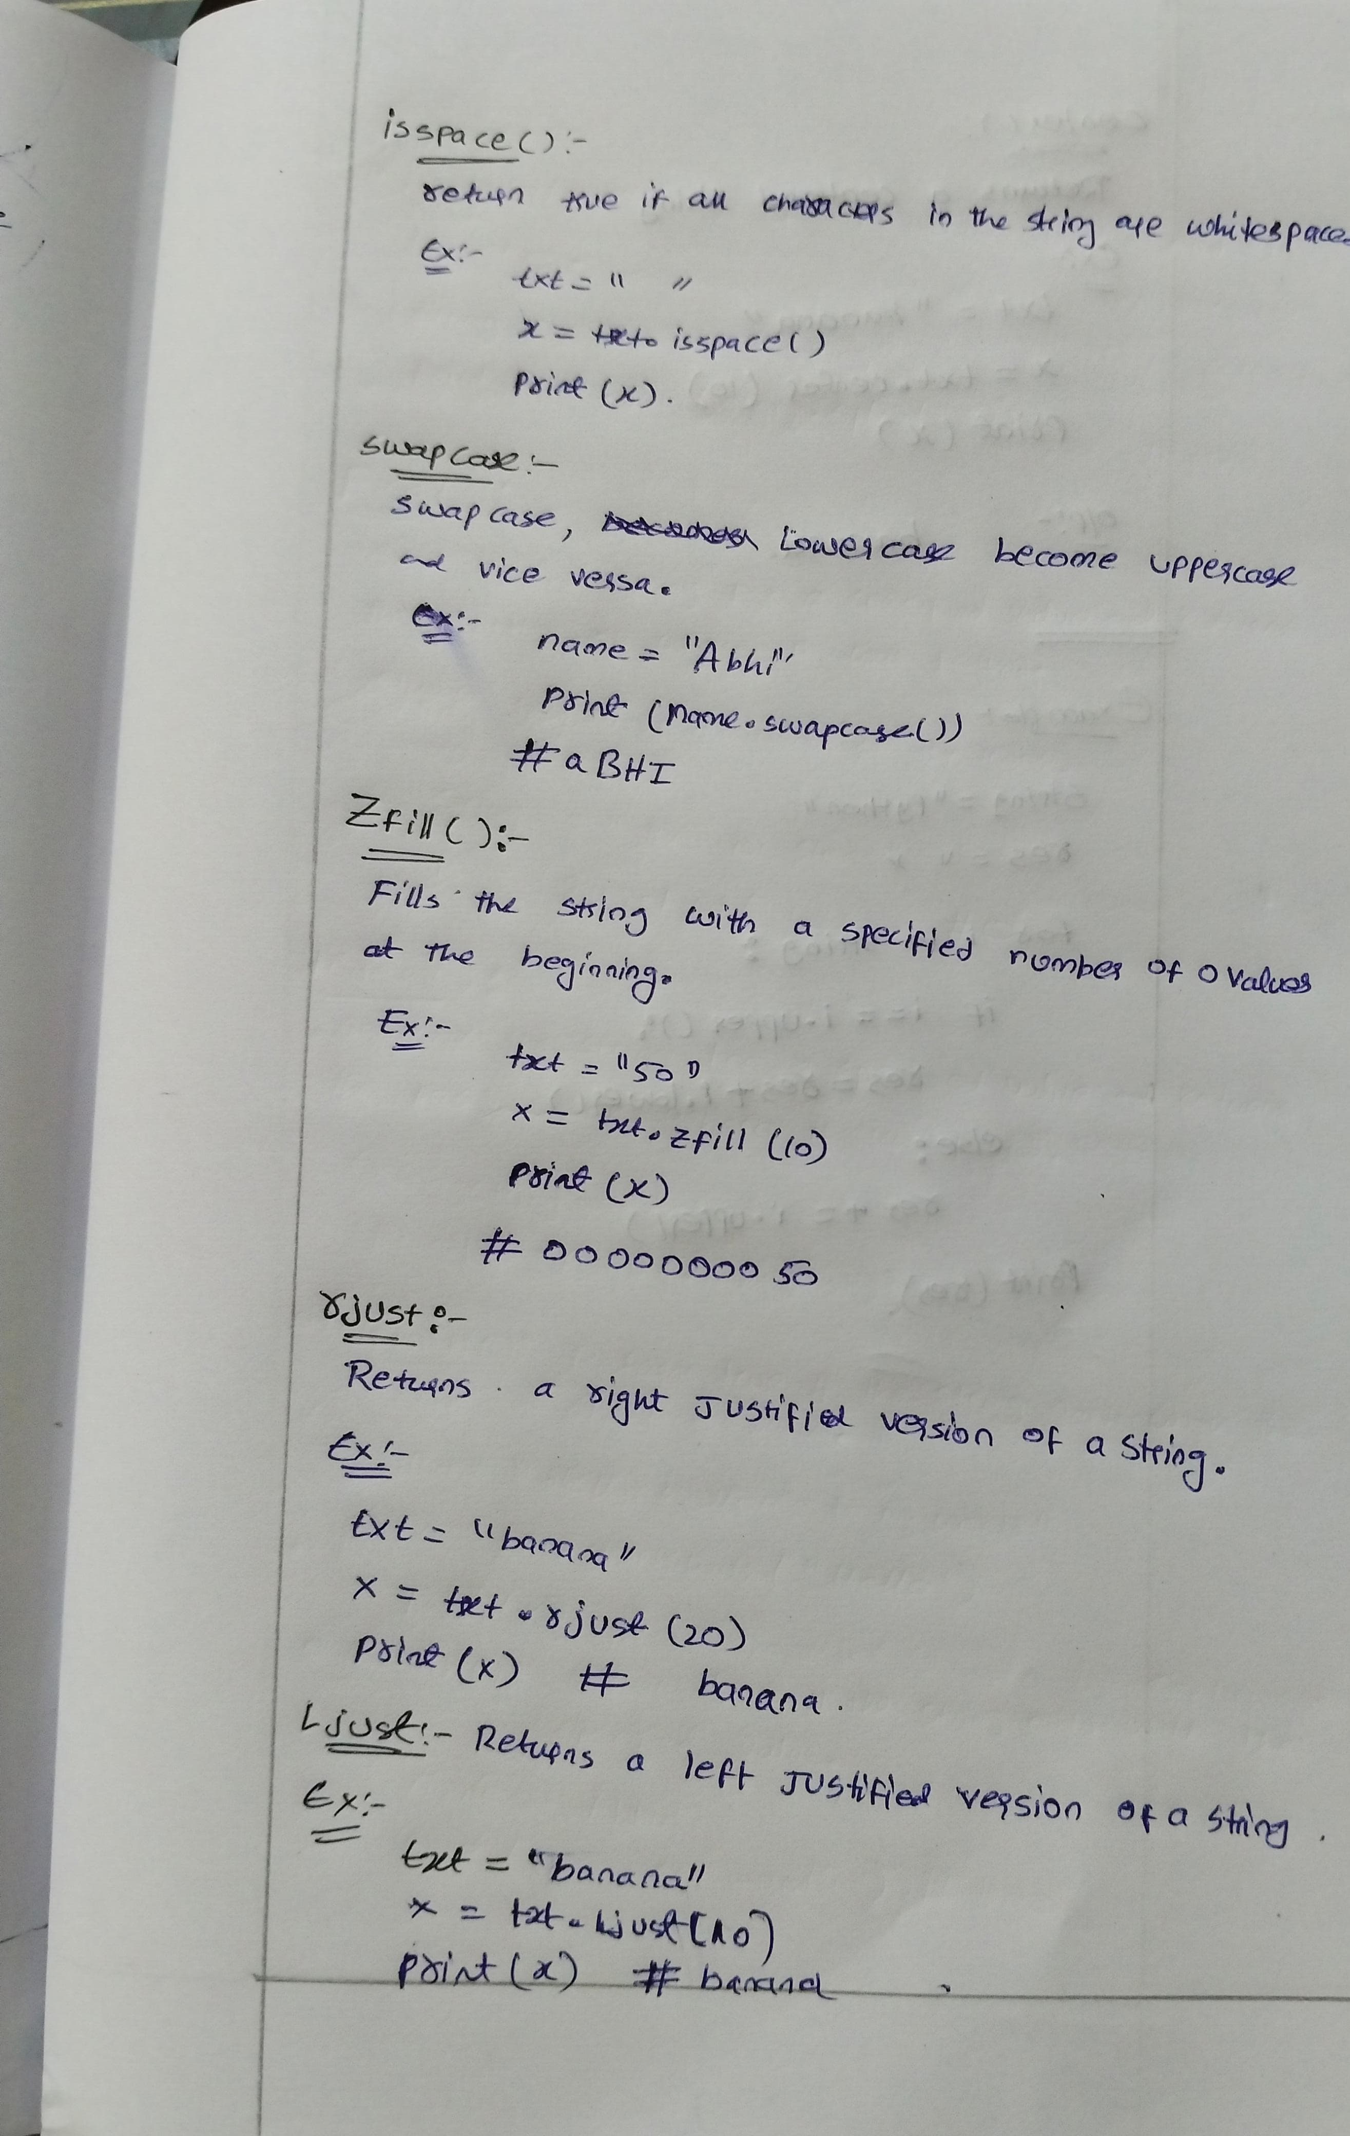

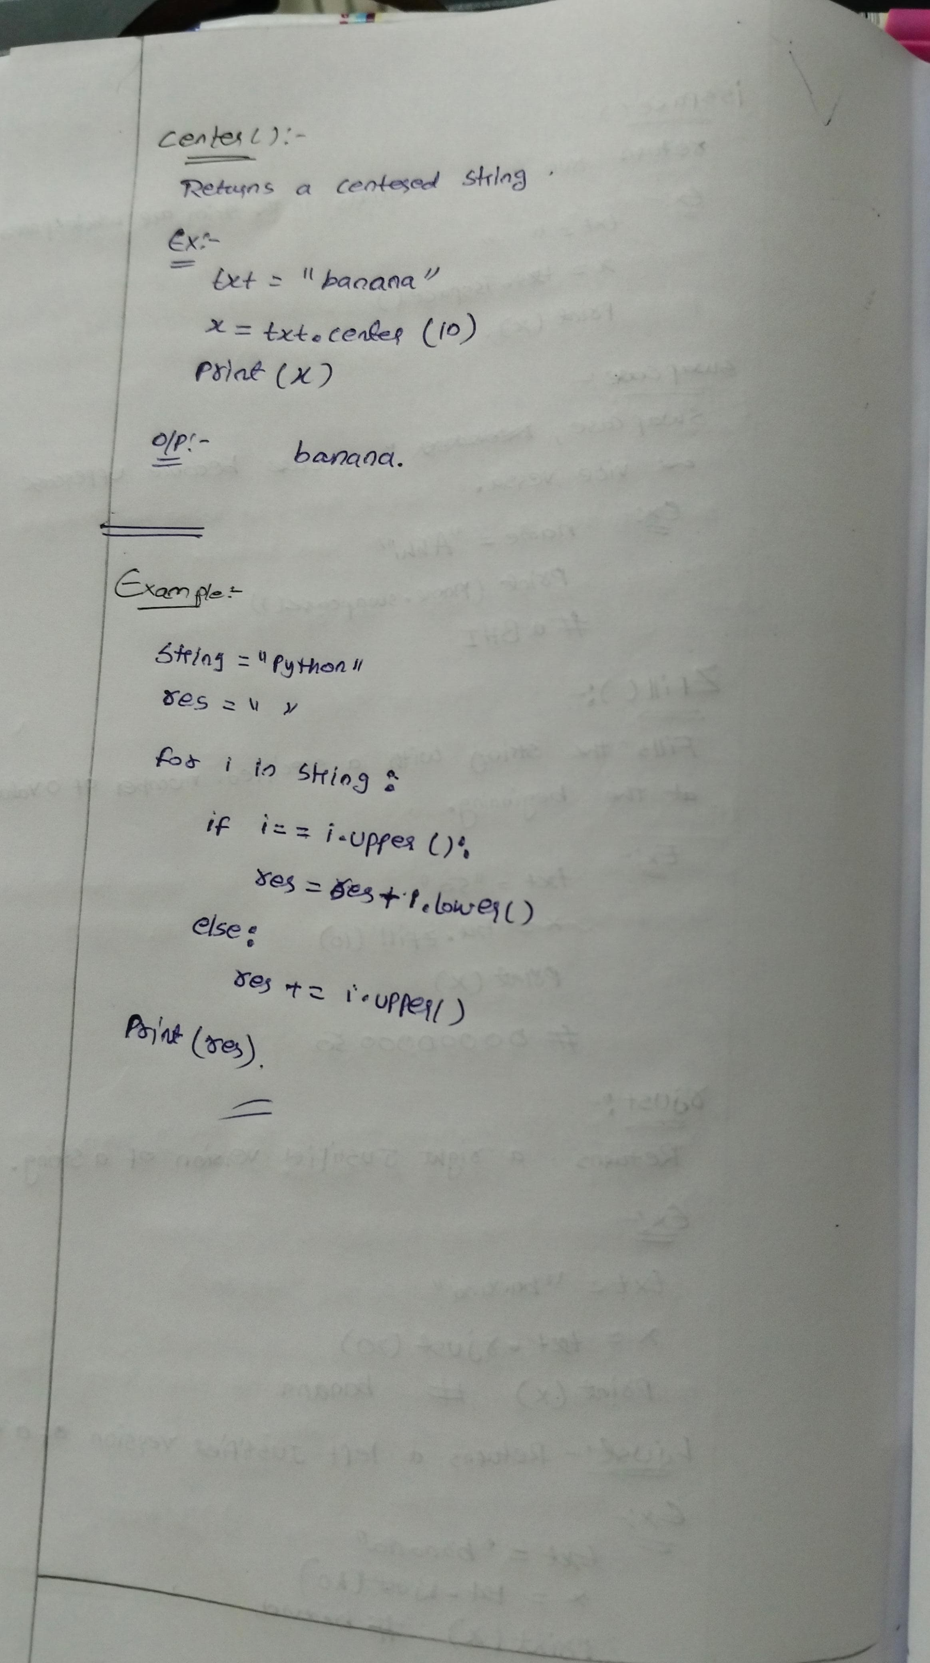

**Number and Number methods:**

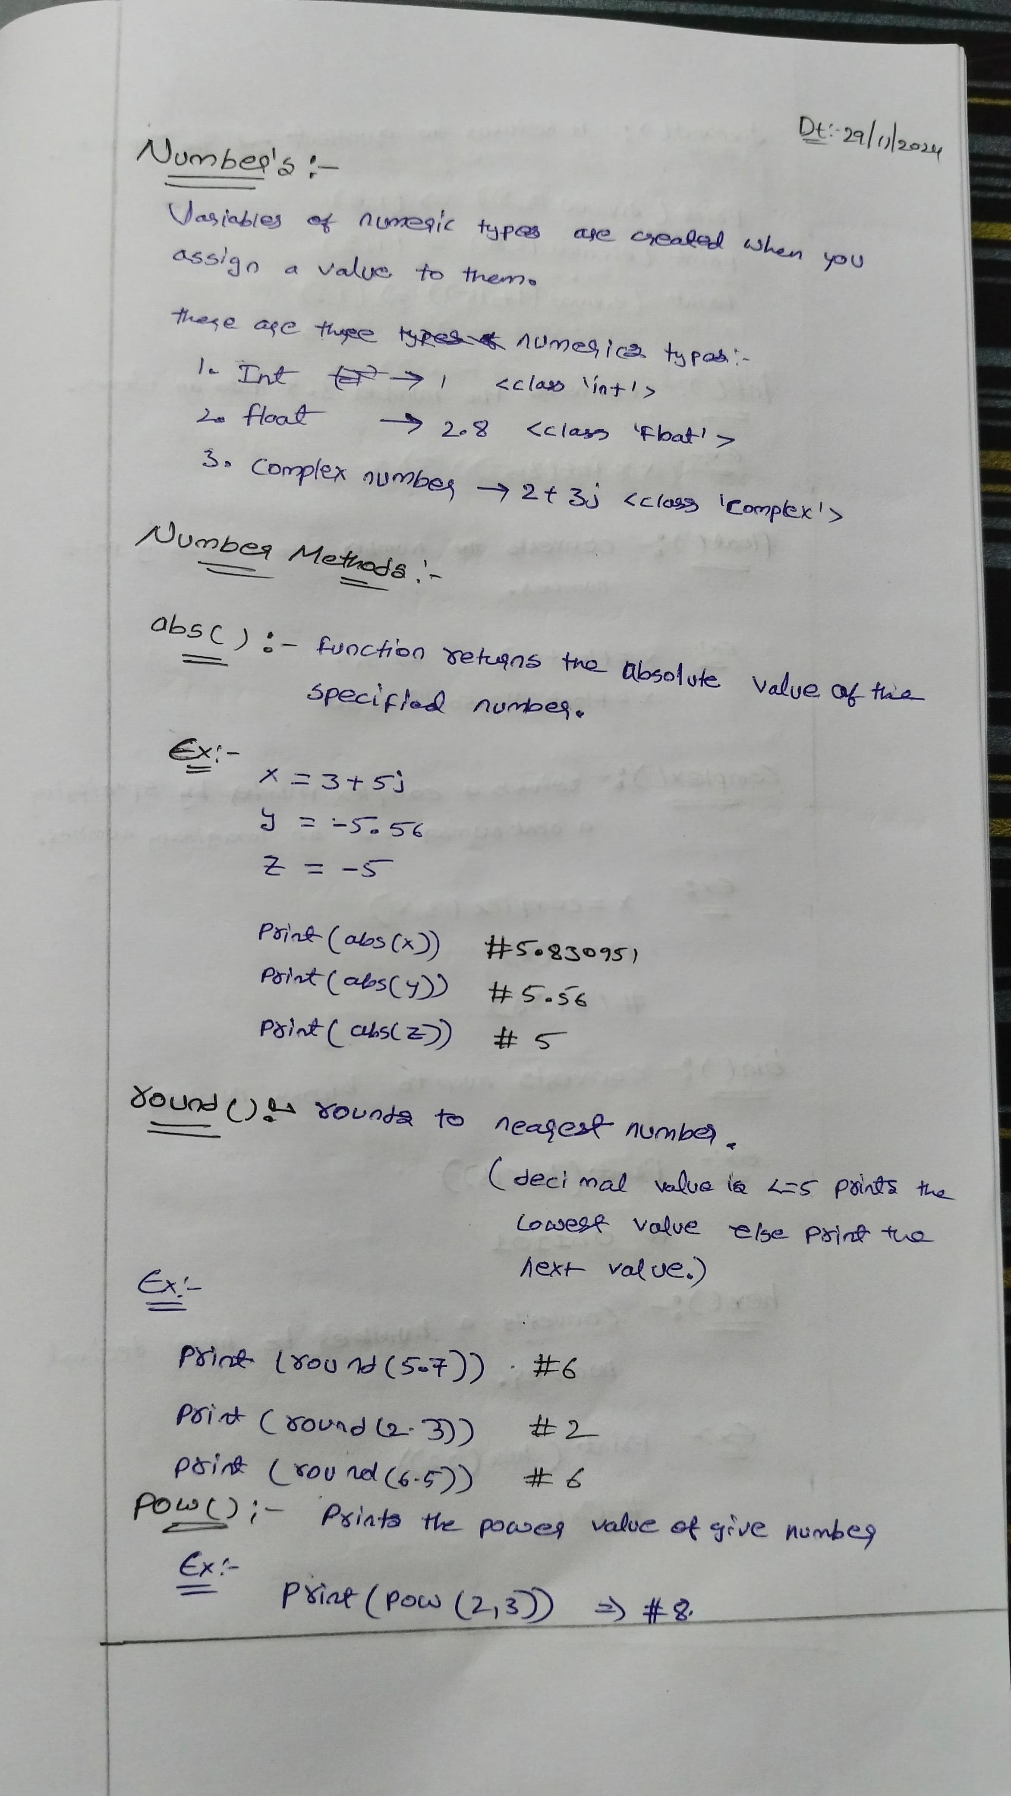

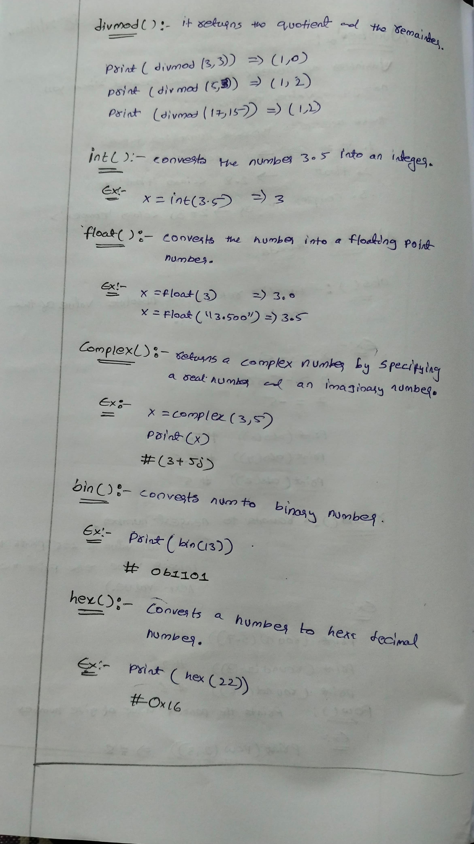

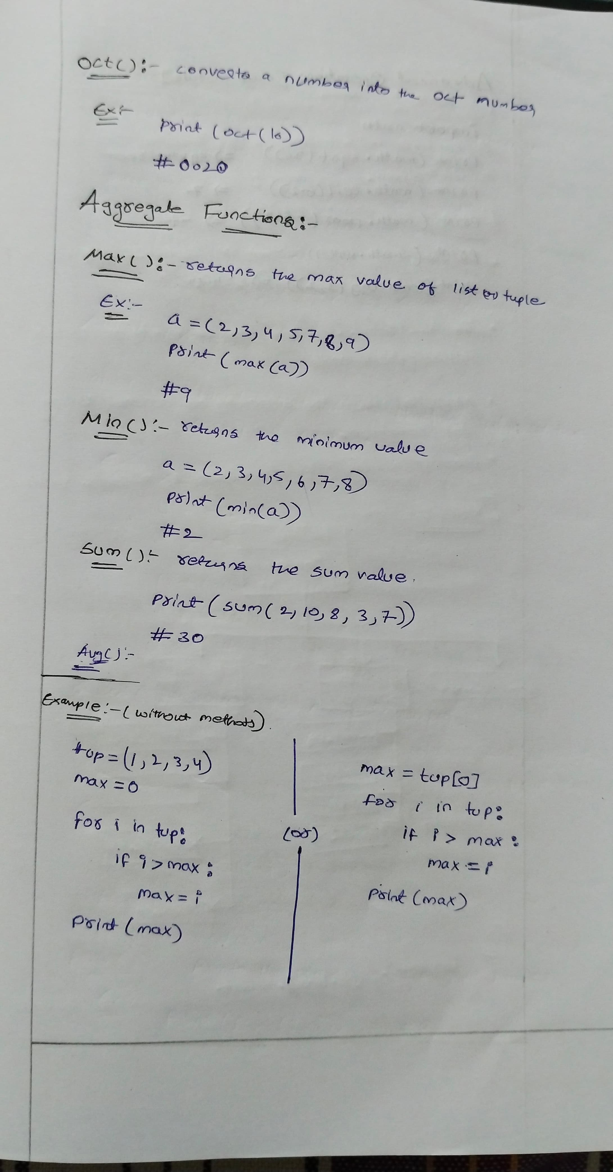

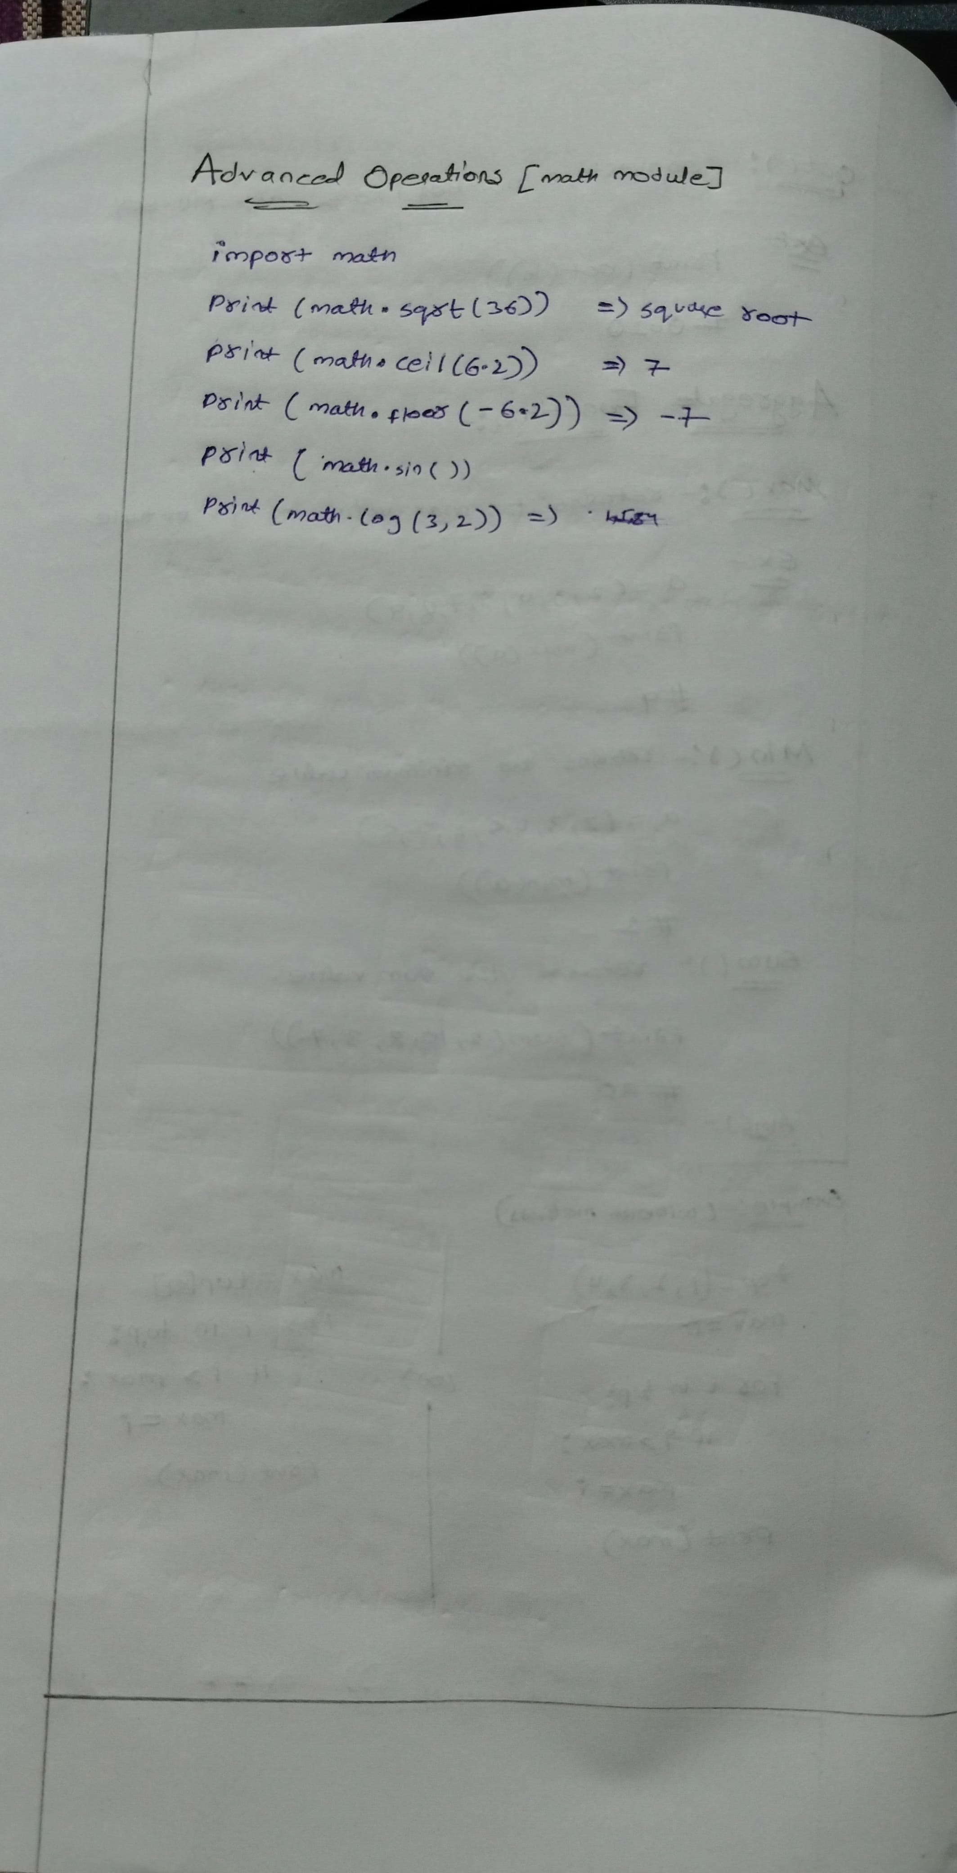

**Modules:**

**Python Module** is a file that contains built-in functions, classes,**its** and variables. There are many **Python modules**, each with its specific work.

In this article, we will cover all about Python modules, such as How to create our own simple module, Import Python modules, From statements in Python, we can use the alias to rename the module, etc.

**What is Python Module**

A [Python](https://www.geeksforgeeks.org/python-programming-language/)module is a file containing Python definitions and statements. A module can define functions, classes, and variables. A module can also include runnable code.

Grouping related code into a module makes the code easier to understand and use. It also makes the code logically organized.

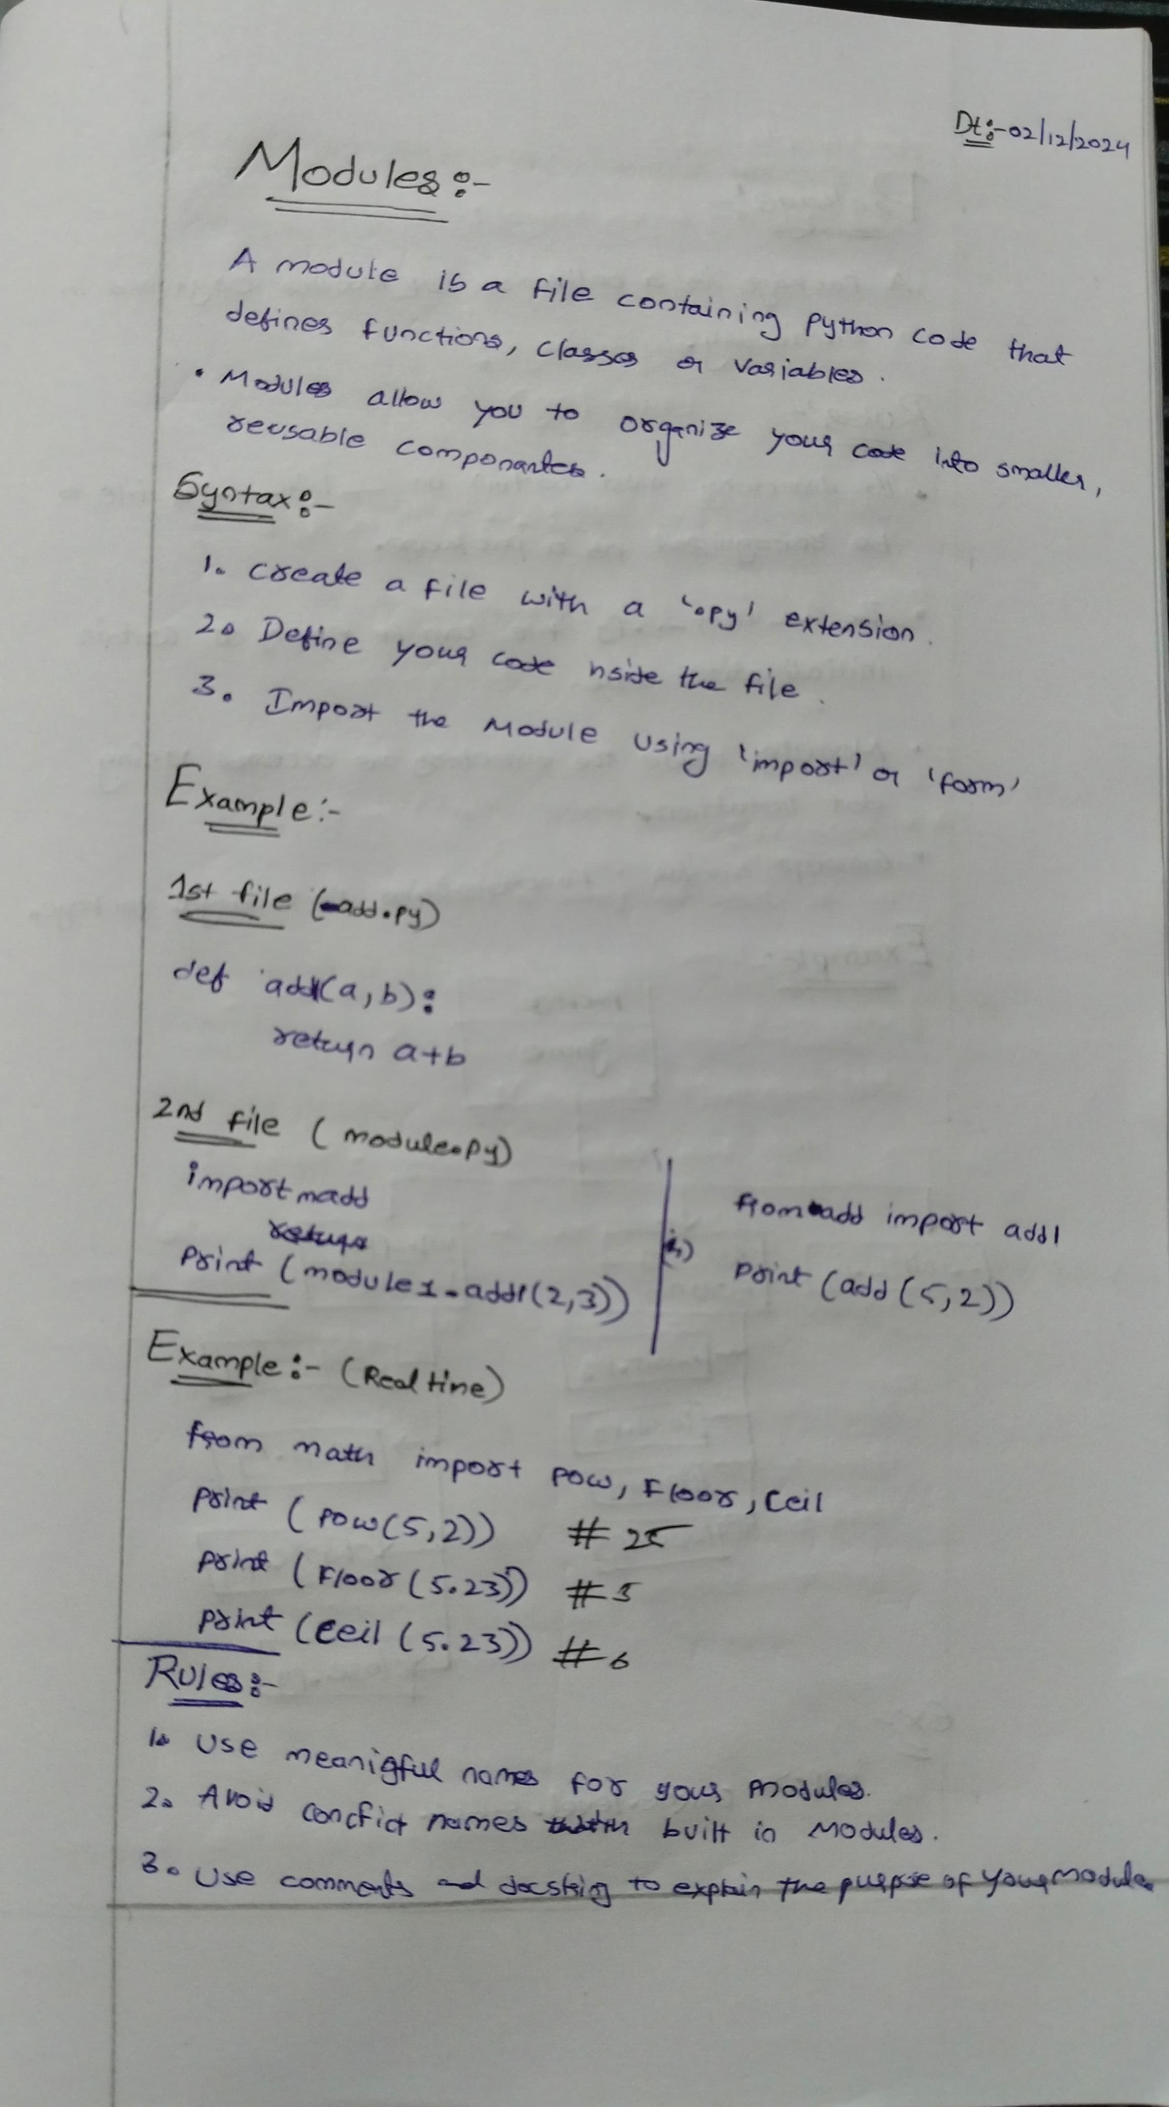

**Packages:**

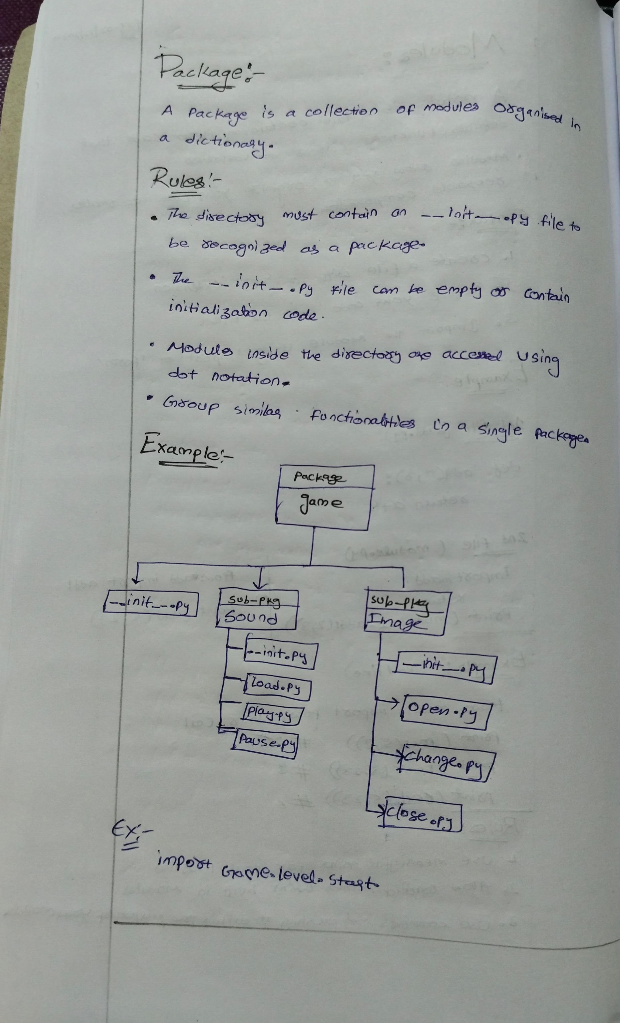

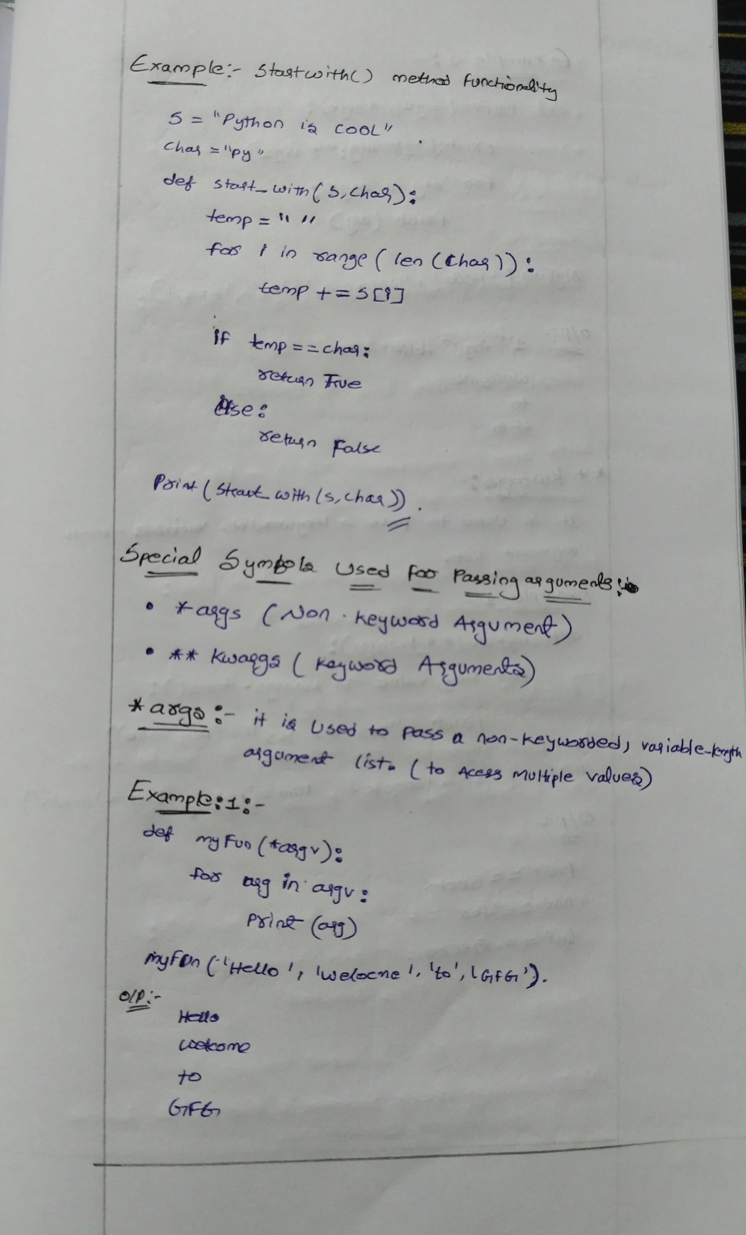

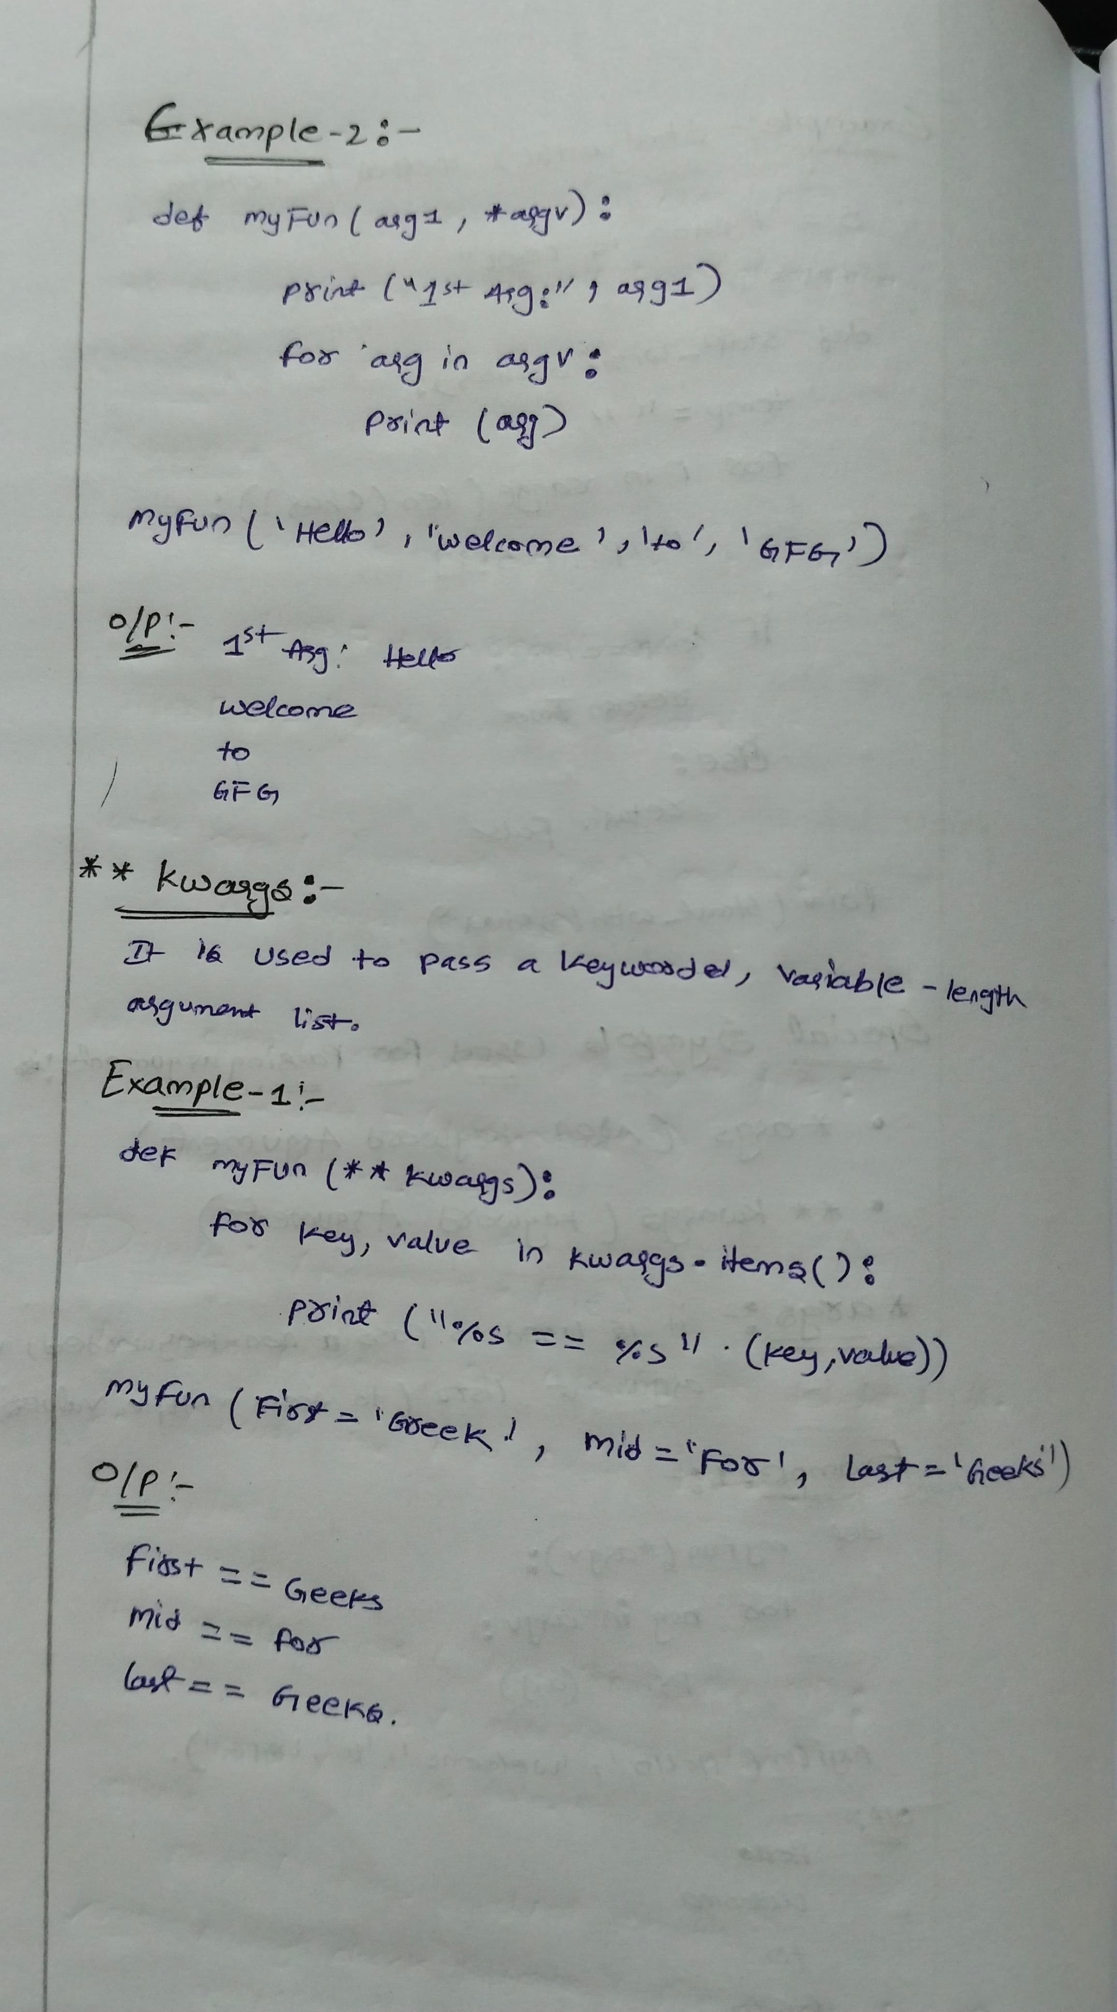

**File Handling:**

file handling and allows users to handle files i.e., to read and write files, along with many other file handling options, to operate on files.

**Advantages of File Handling in Python:** Versatility **,** Flexibility**,** User – friendlyandCross-platform

**File Handling**

The key function for working with files in Python is the open() function.

The open() function takes two parameters; *filename*, and *mode*.

There are four different methods (modes) for opening a file:

* "r" - Read - Default value. Opens a file for reading, error if the file does not exist
* "a" - Append - Opens a file for appending, creates the file if it does not exist
* "w" - Write - Opens a file for writing, creates the file if it does not exist
* "x" - Create - Creates the specified file, returns an error if the file exists

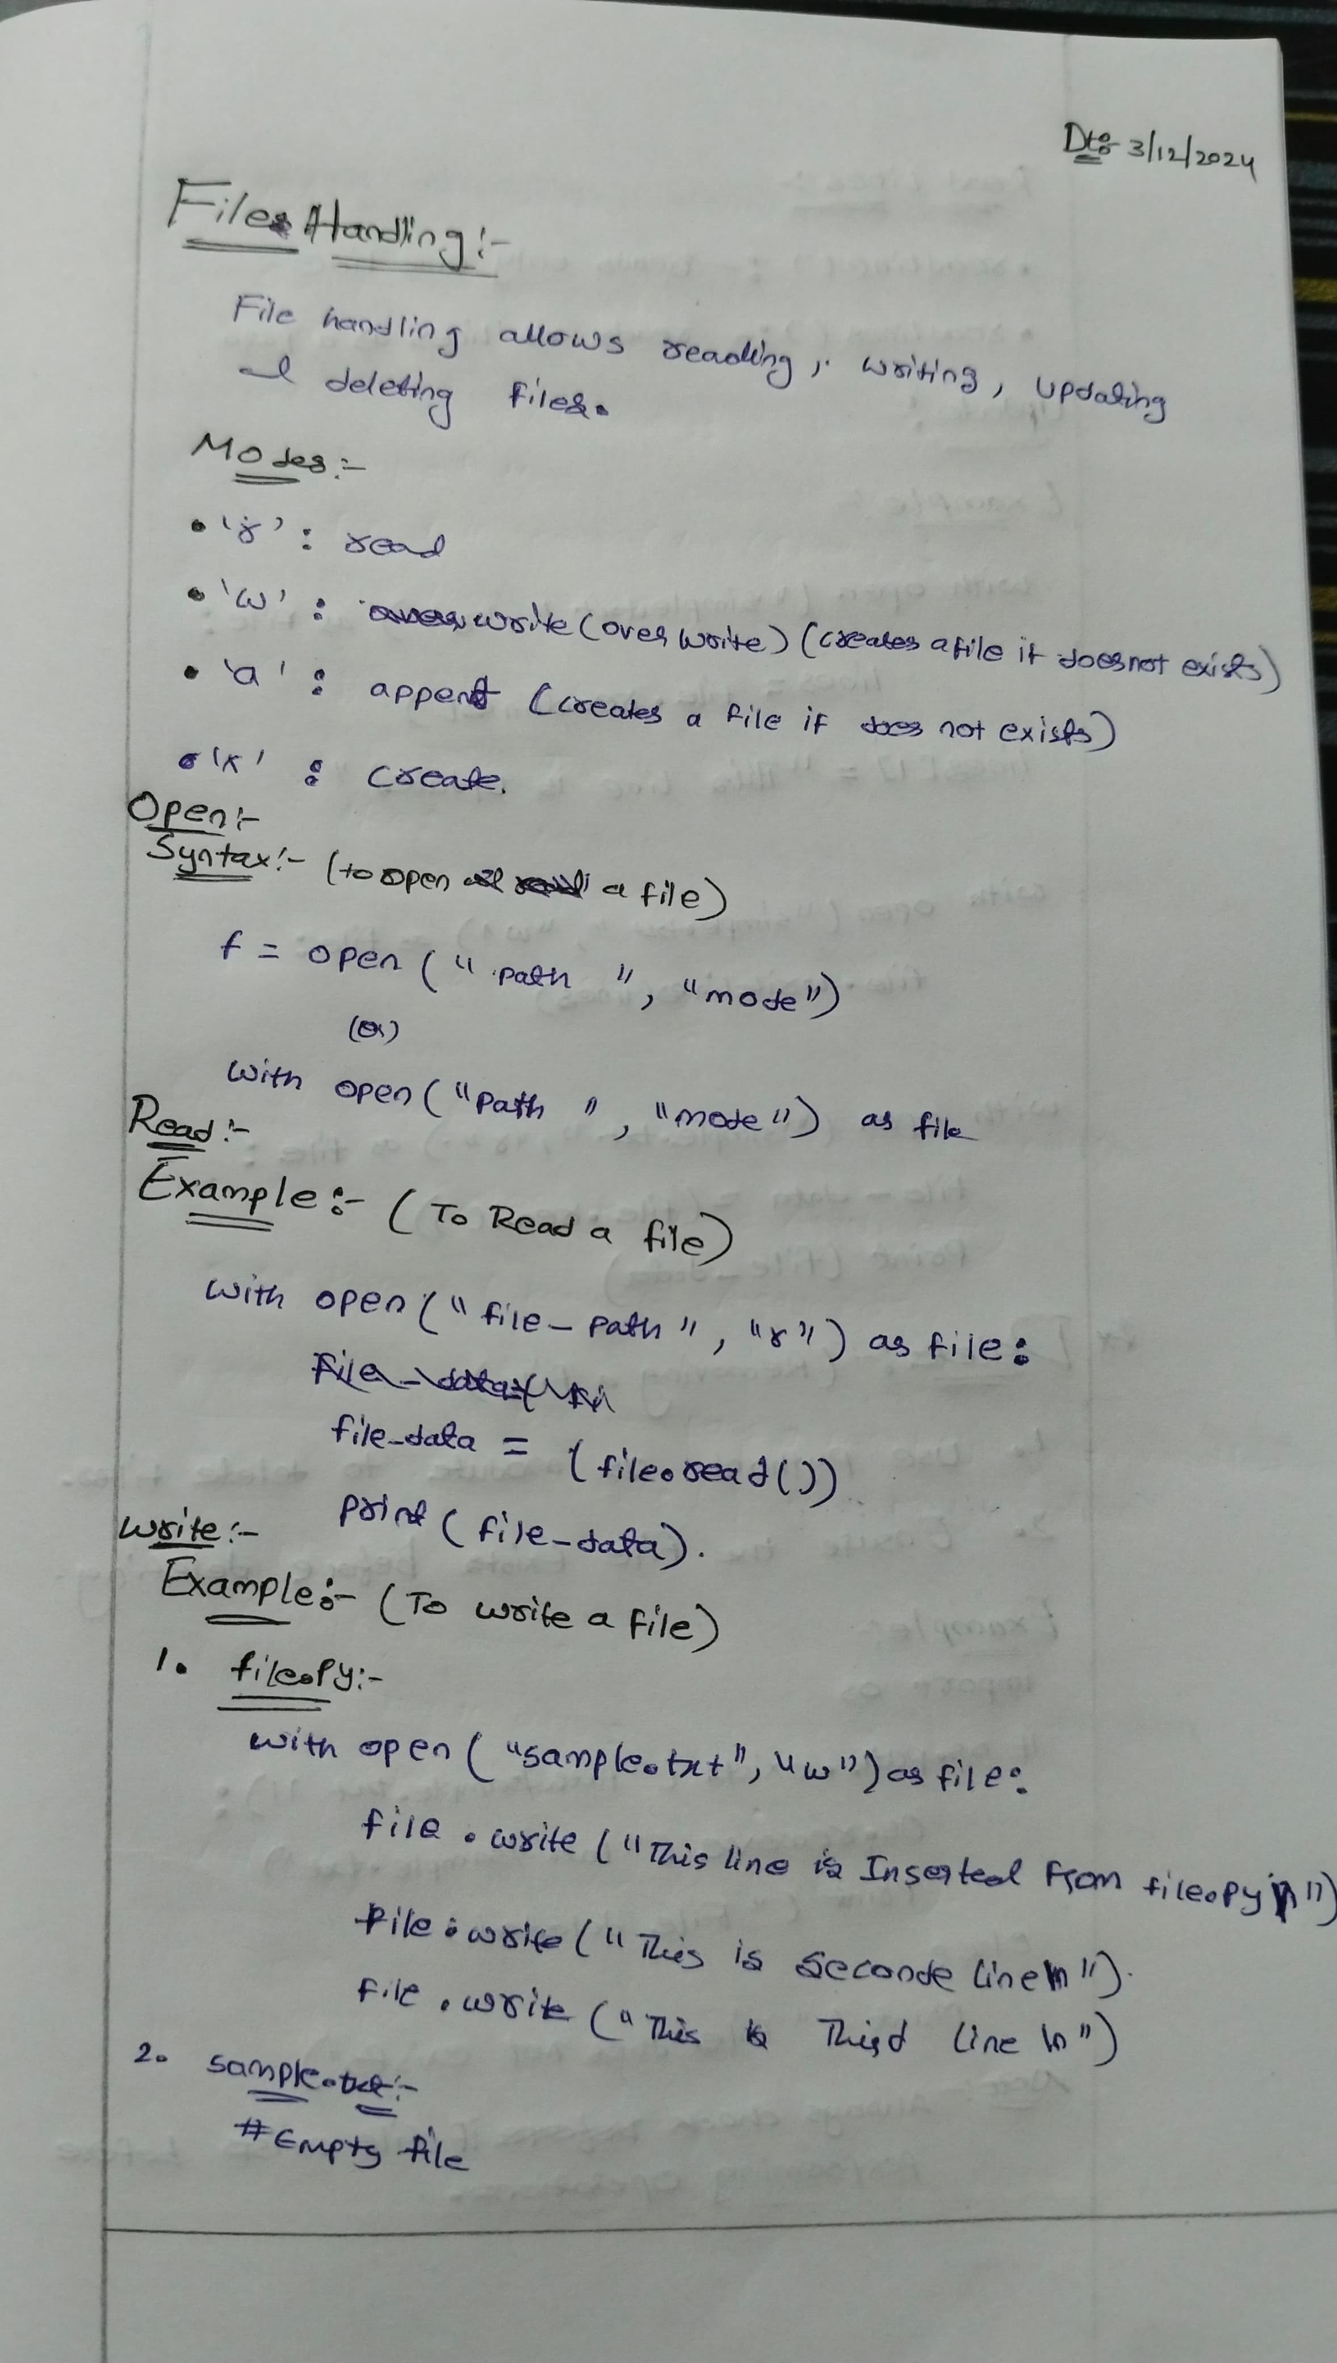

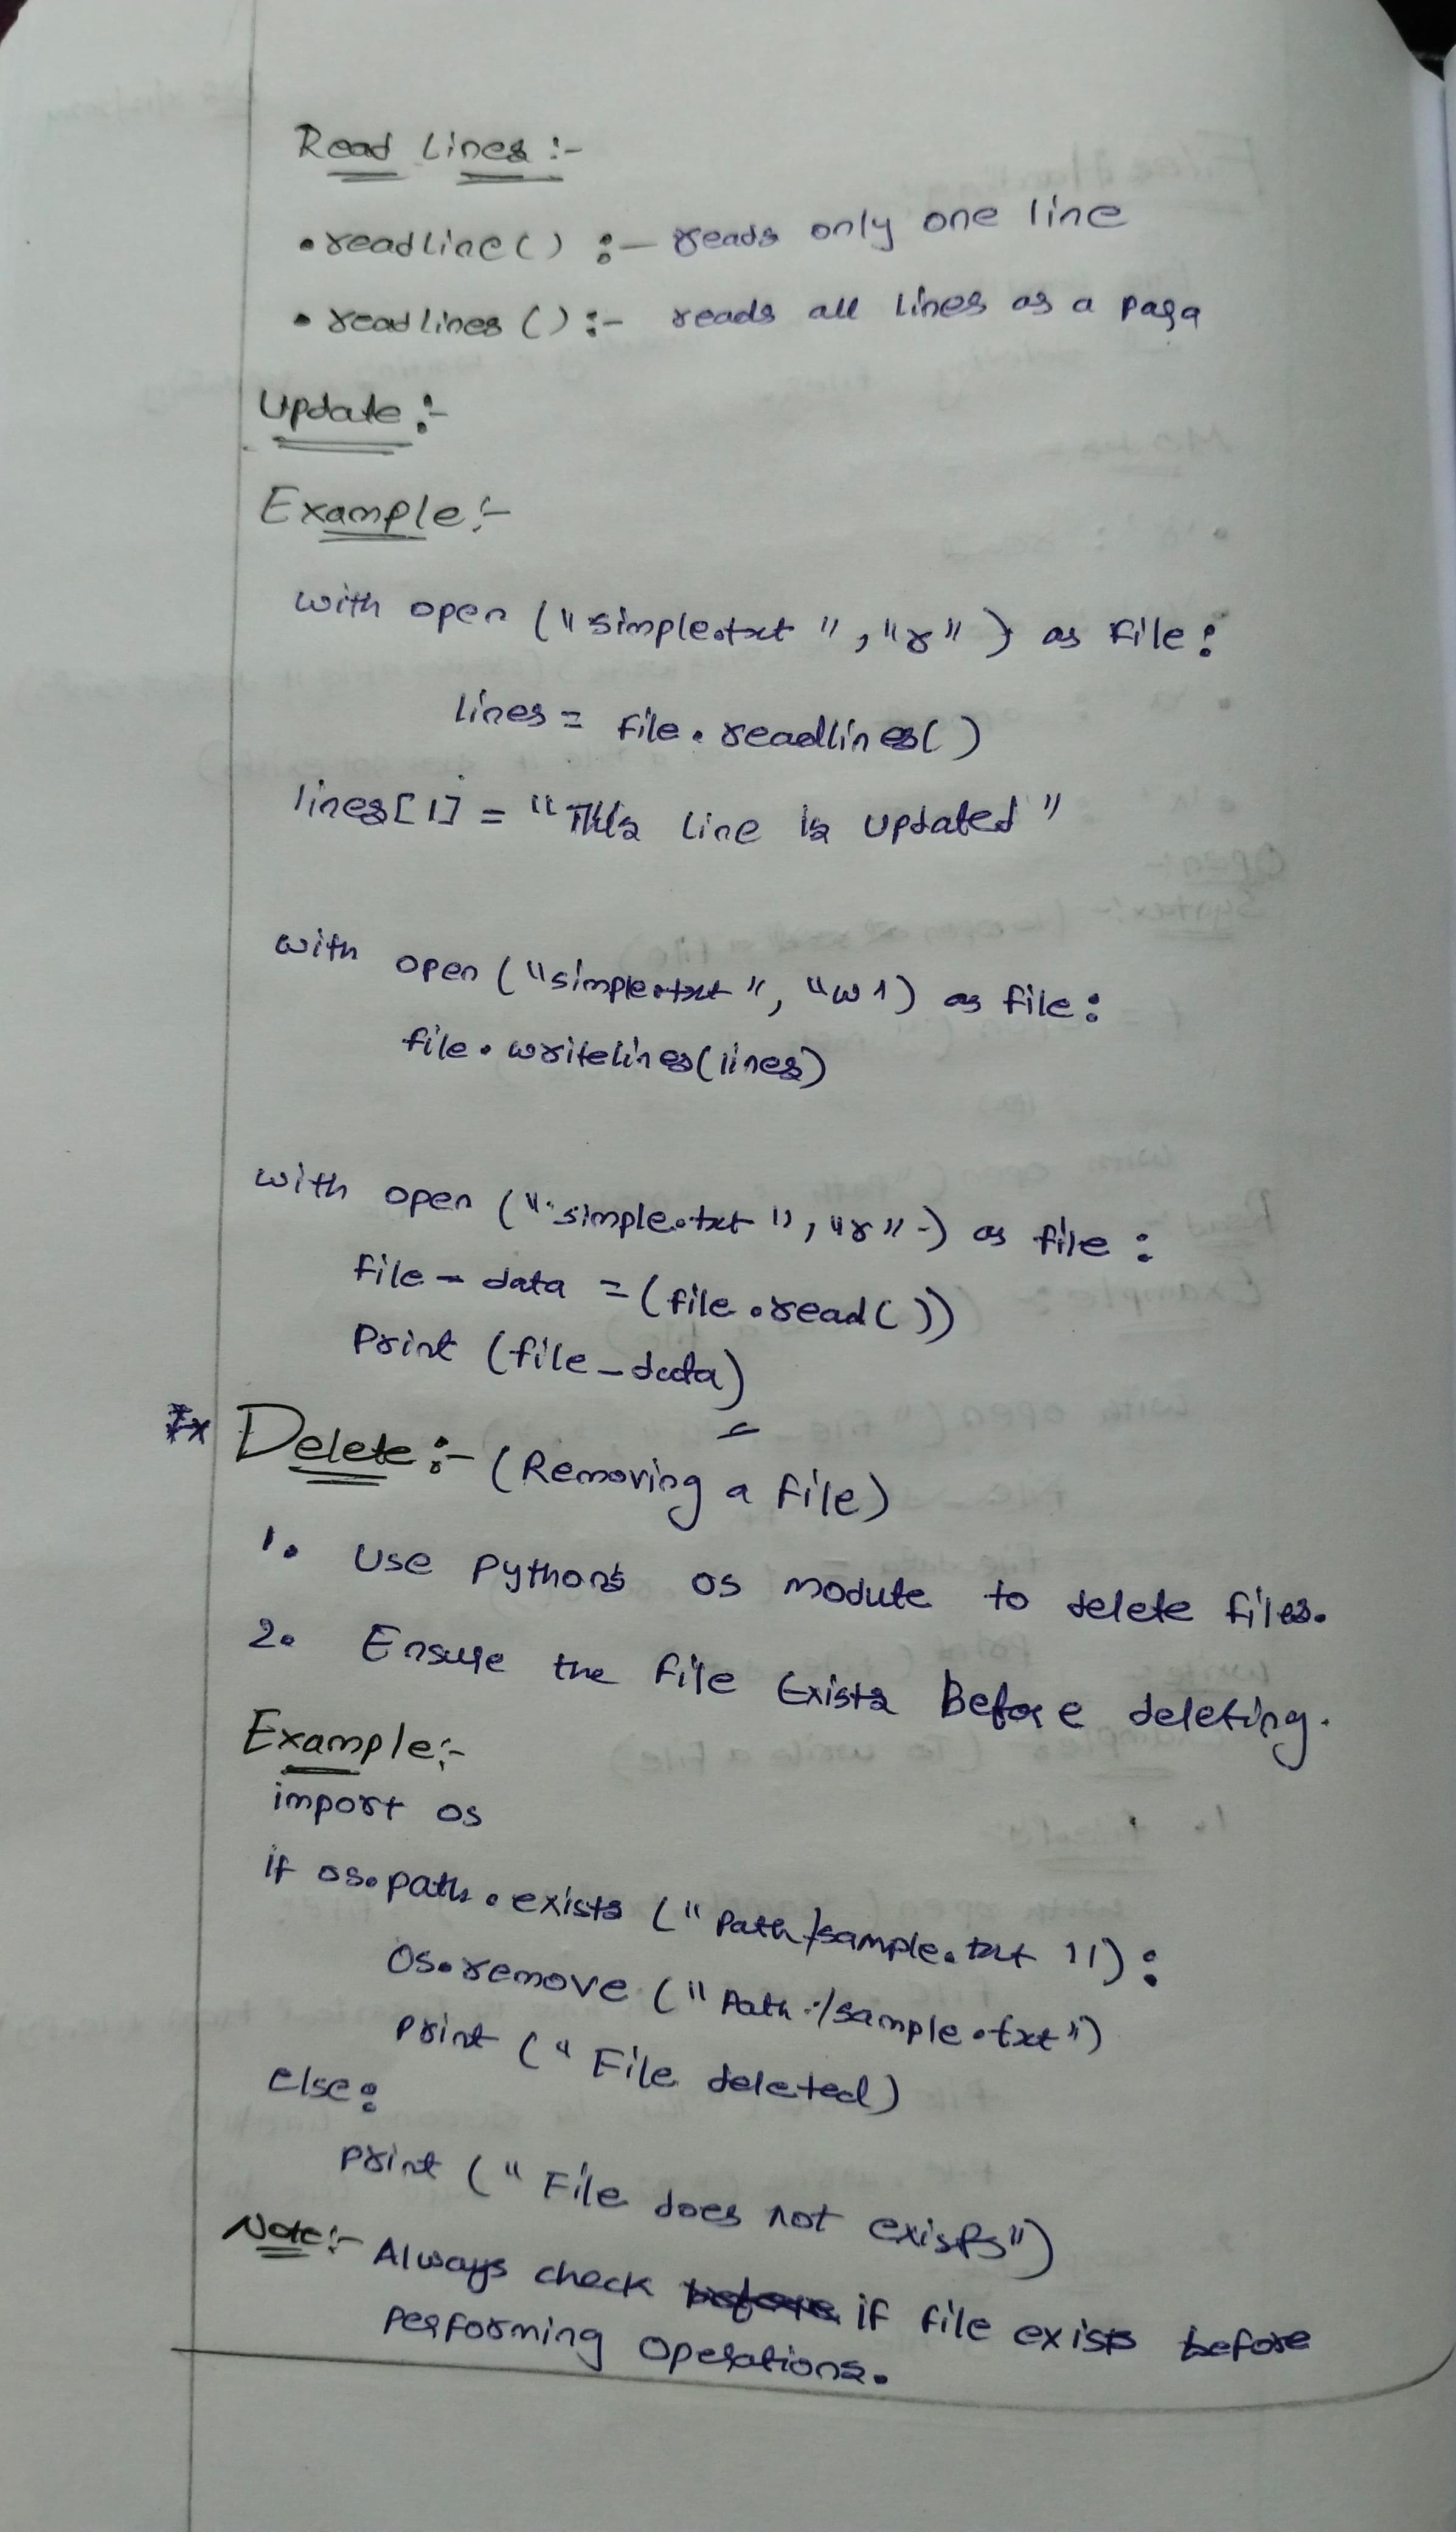

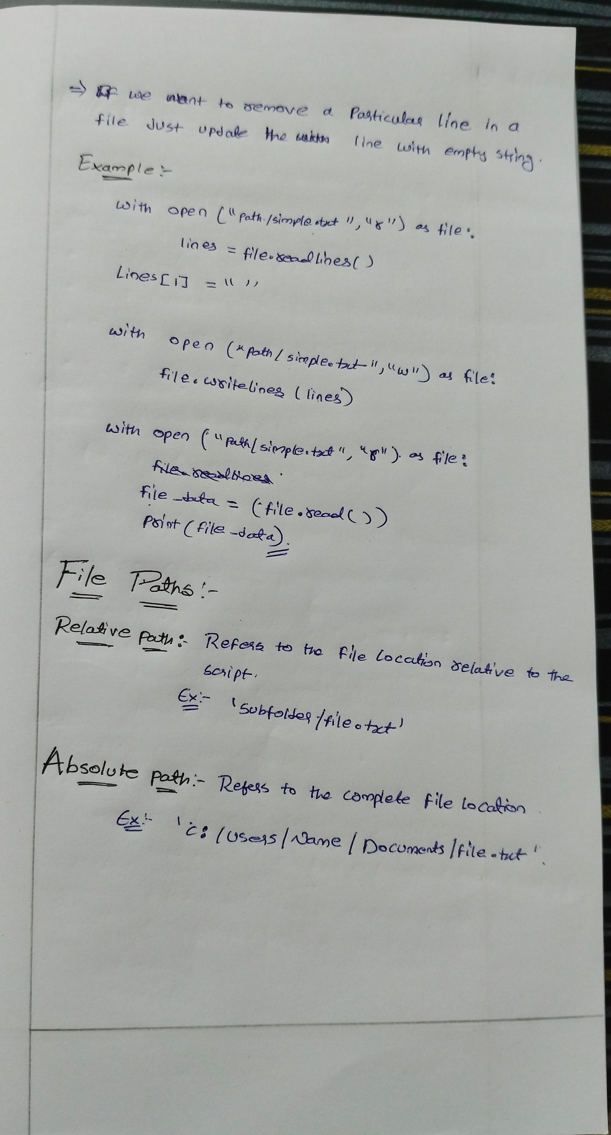

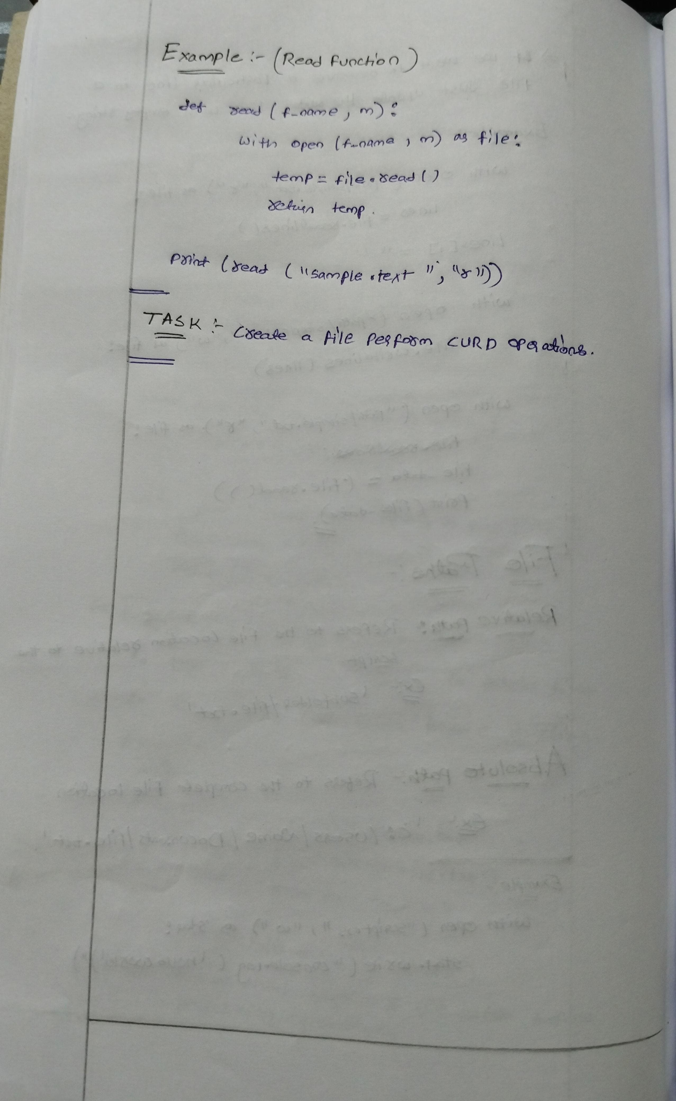

**Regular Expressions**